The Annual Quality Assurance Report (AQAR)

For the Year : 2013–14

Submitted to the

Director,
National Assessment and Accreditation Council
Bangalore – 560 010



By

Internal Quality Assurance Cell

Mangaldai College
Mangaldai – 784 125
Darrang (Assam), India
www.mangaldaicollege.org

2014

Contents

Forwarding from the Principal ...................................................................................................... 3
AQAR of IQAC for the year 2013–14 ..................................................................................... 4-57
Part – A : .................................................................................................................................. 4-10
- Details of the Institution ........................................................................................ 4
- IQAC Composition and Activities ........................................................................ 7
Part – B : ................................................................................................................................ 11-31
- Criterion – I : Curricular Aspects ........................................................................ 11
- Criterion – II : Teaching, Learning and Evaluation ............................................ 12
- Criterion – III : Research, Consultancy and Extension ....................................... 15
- Criterion – IV : Infrastructure and Learning Resources ...................................... 19
- Criterion – V : Student Support and Progression ................................................ 21
- Criterion – VI : Governance, Leadership and Management ................................ 25
- Criterion – VII : Innovations and Best Practices ................................................. 30
- Plans of Institutiond for next year ....................................................................... 31
Annexures .............................................................................................................................. 32-57
Annexure-I : Abbreviation ........................................................................................ 32
Annexure-II : Academic Calender ............................................................................. 33
Annexure III : Graphical Representation of Student Feedback ................................. 36
Annexure IV : Best Practice–1 .................................................................................. 52
Annexure V : Best Practice–2 ................................................................................... 54
Annexure VI : SWOT Analysis ................................................................................. 56

OFFICE OF THE PRINCIPAL
MANGALDAI COLLEGE
MANGALDAI, ASSAM-784 125
Phone & Fax : 03713-230036, 094351 85896(M), e-mail : principalnath@gmail.com

Memo No. MC/2017/335 Dated Mangaldai the 27.11.2017

From: Dr. K. K. Nath, M.Sc. Ph.D. Principal,
Mangaldai College, Mangaldai

To
The Director
National Assessment and Accreditation Council
2/4, Dr. Raj Kumar Road, P.O. Box No. 1075, Rajajinagar
Bangalore – 560 010, India

Sub: Submission of “Annual Quality Assurance Report (AQAR)” for the session 2013-14.

Sir,
With reference to the subject cited above, I have the honour to submit herewith one copy of “Annual Quality Assurance Report (AQAR)” of Mangaldai College, prepared by the Internal Quality Assurance Cell (IQAC) for the academic session 2013–14. The report has been prepared as per instruction of NAAC to detail the tangible results achieved in key areas, specially identified by the institutional IQAC at the beginning of the academic year. The AQAR details the results of the perspective plan worked out by the IQAC.
This is for favour of your perusal and necessary action.
Thanking you.

Sincerely, yours



(Dr. K.K.Nath)
Principal,
Mangaldai College, Mangaldai.

The Annual Quality Assurance Report (AQAR) of the IQAC

Part – A

1. Details of the Institution
MANGALDAI COLLEGE
1.1 Name of the Institution
Vill.: Upahupara
1.2 Address Line 1
Mangaldai

Address Line 2
Mangaldai
City/Town
Assam
State
784 125
Pin Code
principalnath@gmail.com
Institution e-mail address
+919435185896
Contact Nos.
Dr. Khagendra Kumar Nath
Name of the Head of the Institution:
03713-230036
Tel. No. with STD Code:
+919435185896

Mobile:

Mr. Paresh Kumar Sarmah
Name of the IQAC Co-ordinator:
Mobile:
+919435006483
mciqac@gmail.com
IQAC e-mail address:

1.3 NAAC Track ID (For ex. MHCOGN 18879) : NIL
EC/32/A&A/255 dated 03-05-2004

1.4 NAAC Executive Committee No. & Date :
www.mangaldaicollege.org
1.5 Website address:
www.mangaldaicollege.org/AQAR,2013-14.doc
Web-link of the AQAR:

1.6 Accreditation Details
Sl. No. | Cycle | Grade | CGPA | Year of Accreditation | Validity Period
1 | 1st Cycle | C++ |  | 2004 | 2004 - 2009
2 | 2nd Cycle
3 | 3rd Cycle
4 | 4th Cycle

1.7 Date of Establishment of IQAC : DD/MM/YYYY
13/06/2005

2013-14
1.8 AQAR for the year (for example 2010-11)

1.9 Details of the previous year’s AQAR submitted to NAAC after the latest Assessment and Accreditation by NAAC ((for example AQAR 2010-11submitted to NAAC on 12-10-2011)
- AQAR 2012-13 (27/11/2017)
1.10 Institutional Status


University State Central Deemed Private


Affiliated College Yes No
Constituent College Yes No



Autonomous college of UGC Yes No





Regulatory Agency approved Institution Yes No
(eg. AICTE, BCI, MCI, PCI, NCI)


Type of Institution Co-education Men Women



Urban Rural Tribal





Financial Status Grant-in-aid UGC 2(f) UGC 12B

Grant-in-aid + Self Financing Totally Self-financing

1.11 Type of Faculty/Programme


Arts Science Commerce Law PEI (Phys Edu)



TEI (Edu) Engineering Health Science Management

Distance Education Programme under KKHSOU, IDOL.
H.S. Course under AHSEC.
Others (Specify)

1.12 Name of the Affiliating University (for the Colleges)
Gauhati University

1.13 Special status conferred by Central/ State Government-- UGC/CSIR/DST/DBT/ICMR etc

Autonomy by State/Central Govt. / University

University with Potential for Excellence UGC-CPE



DST Star Scheme UGC-CE

UGC-Special Assistance Programme DST-FIST

UGC-Innovative PG programmes Any other (Specify)

UGC-COP Programmes
2. IQAC Composition and Activities
06
2.1 No. of Teachers
00

2.2 No. of Administrative/Technical staff
00

2.3 No. of students
2.4 No. of Management representatives
00

00
2.5 No. of Alumni
2. 6 No. of any other stakeholder and
00

community representatives
00

2.7 No. of Employers/ Industrialists

2.8 No. of other External Experts
02

2.9 Total No. of members
03
]’
loiouyr
09

2.10 No. of IQAC meetings held
01

00

2.11 No. of meetings with various stakeholders: No. Faculty
00

00

00
Non-Teaching Staff Students Alumni Others
2.12 Has IQAC received any funding from UGC during the year? Yes No
3.00 lakh


If yes, mention the amount
2.13 Seminars and Conferences (only quality related)
(i) No. of Seminars/Conferences/ Workshops/Symposia organized by the IQAC
01

0000

00

00

01

Total Nos. International National State Institution Level
Enhancement of quality in Research
“Familiarization to the equipments procured in Institutional Level Biotech Hub” 23rd May, 2014

(ii) Themes

2.14 Significant Activities and contributions made by IQAC
a) Self appraisal report of individual teachers were collected by the IQAC to keep a record of the different activities of the faculty members.

b) Student Feedback on teachers was collected and analysed by the IQAC and submitted to the Principal for necessary action.
c) The IQAC encouraged the faculty members to take up project work and research activities through proper monitoring by the Research Committee formed recently.

d) The IQAC prepared a format for the Daily Class Diary and Monthly Progress Report and ensured the submission of filled in form duly signed by the HOD to the Principal every month.

2.15 Plan of Action by IQAC/Outcome
The plan of action chalked out by the IQAC in the beginning of the year towards quality
enhancement and the outcome achieved by the end of the year *
Plan of Action | Achievements
- Improving physical facilities available in the academic campus by focusing on the addition of new classroom, completion of half done Science Gallery with modern audio-visual equipments, shifting of UGC-Network Resource Centre to RCC building and continuation of ongoing construction of Indoor sports stadium and Swimming pool. | - Construction of RCC Class rooms is going on from the grant of Rs. 1 Crore sanctioned by Govt. of Assam, Science Gallery with modern audio-visual equipments is now functional and shifting of UGC-Network Resource Centre(with latest PCs and OS) to RCC building are completed. The ongoing construction of Indoor sports stadium and Swimming pool is continuing and progress report submitted to UGC.
2. Improving water supply network throughout the campus and providing pure drinking water facilities with cooler to teachers, employees and students. | - 24 hour water supply has been provided to various science departments by replacing old plumbing and pure drinking water facilities with coolers are provided. The work will continue in the next session.
- Purchasing equipments and recruitment of JRF for Institutional Level Biotech sanctioned by DBT, New Delhi. | 3. All proposed equipments for Biotech Hub have been purchased and one JRF has been recruited.
- Beautification and plantation in college campus. | - Gardening and Plantation are on-going projects.
- Initiating recruitment of permanent faculty in Computer Science Department. | - A proposal for recruitment of permanent faculty in Computer Science Department has been submitted to the Govt. Of Assam.
- Submission of revised proposal to Dept. Of Social Welfare, GOI for construction Boys’ Hostel Building. | - The proposal is under process.
- Encouraging the faculty members for Research works. | - One faculty member has been released for higher study leading to Ph.D. under UGC-FDP during XIIth plan. Three more faculty members have applied for the same. One faculty member has been able to get DST-sponsored major project and another faculty member has got one UGC-minor project. Three more faculty members have applied for UGC-minor projects.
- Introducing a new theory paper on Research Methodology for 6th Semester Major Students (Department : Botany, Chemistry, Physics and Zoology) under Star College Scheme. | - A syllabus has been prepared and passed by the Research Committee of the College and the paper will be introduced in the next academic session.
- Improving library services by computerization of library functions, new acquisitions and enhancing access. | - The work is in progress.
- Exploring the possibilities of Foreign Collaboration in Research | 10. The expression of interest has been sent to Bowling Green State University in the proposal “The role of structural connectivity on environmental stability to climate change: Implications for food production in India.” The School of Geography, University of Leeds is happy to be listed as a partner site in this proposal.
- Defending the proposal for DBT – Star College Scheme before expert committee of DBT, New Delhi. | 11. The Coordinator of the scheme successfully defended the proposal due to which DBT sanctioned the proposal.
- Completion of revival the College fishery damaged by flood waters. | 12. The work has been completed.
- Opening of a branch of a Nationalised Bank of the campus. | 13. A branch of Bank of Baroda was opened on 21/12/2013.
* Attach the Academic Calendar of the year as Annexure-II

2.15 Whether the AQAR was placed in statutory body Yes No




Management Syndicate Any other body
Provide the details of the action taken
The management i.e. the Governing body of the college had authorized the Principal-cum-Chairperson of IQAC to take necessary steps on the plan of action chalked out by the IQAC subject to the availability of funds. Some of the action taken in this year are :
- The IQAC has been re-constituted as per the latest UGC-NAAC guidelines on 29/04/2014 for vibrant quality related activities.
- The construction committee has been re-constituted as per the latest UGC guidelines to look after the ongoing construction works.
- Continuation of construction work of RCC Class Room from the grant of Rs. 1 crore by the Government of Assam.
- Completion of the Science Gallery with modern audio-visual equipments.
- Shifting of the UGC-Network Resource Centre (with latest PCs and OS) to a RCC building.
- Provision of 24 hour water supply has been provided to various science departments and the canteen by replacing old plumbing.
- Provision of pure drinking water facilities with cooler in the campus.
- Continuation of construction of the Indoor sports stadium along with the Swimming-pool.
- Purchase of proposed equipments and recruitment of JRF for Institutional Level Biotech Hub.
- Continuation of beautification and plantation of the College campus.
- Submission of proposal to the Government of Assam for recruitment of permanent faculty in Computer Science Department.
- Initiation of the process for filling up the vacant posts.
- Preparation of the syllabus for the newly introduced paper on Research Methodology.
- Initiation for the improvement of library services.
- Exploring the possibility for foreign collaboration in Research in Geography.

Part – B
Criterion – I

1. Curricular Aspects

1.1 Details about Academic Programmes
Level of the Programme | Number of existing Programmes | Number of programmes added during the year | Number of self-financing programmes | Number of value added / Career Oriented programmes
PhD | 02 | 00 | 02 | 00
PG | 01 | 00 | 01 | 00
UG | 02 | 00 | 00 | 00
PG Diploma(PGDCA) | 01 | 00 | 01 | 00
Advanced Diploma | 00 | 00 | 00 | 00
Diploma(DOAEC) | 01 | 00 | 01 | 00
Certificate
Others (H.S.) | 02 | 00 | 00 | 00
Total | 09 | 00 | 05 | 00

Interdisciplinary
Innovative

1.2 (i) Flexibility of the Curriculum: CBCS/Core/Elective option / Open options : Elective Option
(ii) Pattern of programmes:
Pattern | Number of programmes
Semester | 03
Trimester | 00
Annual | 01



1.3 Feedback from stakeholders* Alumni Parents Employers Students
(On all aspects)



Mode of feedback : Online Manual Co-operating schools (for PEI)
*Please provide an analysis of the feedback in the Annexure

1.4 Whether there is any revision/update of regulation or syllabi, if yes, mention their salient aspects.
No

1.5 Any new Department/Centre introduced during the year. If yes, give details.
Institutional level of Biotech Hub has been established vide letter no. BT/32/NE/2012, 19/09/2013

Criterion – II
2. Teaching, Learning and Evaluation
2.1 Total No. of permanent faculty
Total | Asst. Professors | Associate Professors | Professors | Others
73 | 33 | 29 | 00 | 00
Note : 11 posts of Assistant Professor are vacant as on June, 2014
20
2.2 No. of permanent faculty with Ph.D.
2.3 No. of Faculty Positions Recruited (R) and Vacant (V) during the year
Asst. Professors |  | Associate Professors |  | Professors |  | Others |  | Total
R | V | R | V | R | V | R | V | R | V
00 | 00 | 00 | 02 | 00 | 00 | 00 | 00 | 00 | 02
00
00
06
2.4 No. of Guest and Visiting faculty and Temporary faculty

2.5 Faculty participation in conferences and symposia:

No. of Faculty | International level | National level | State level
Attended Seminars/ Workshops | 03 | 20 | 27
Presented papers | 01 | 07 | 00
Resource Persons | 00 | 00 | 00

2.6 Innovative processes adopted by the institution in Teaching and Learning:
Two traditional classrooms were converted into digital smart classrooms.

176
2.7 Total No. of actual teaching days
during this academic year
2.8 Examination/ Evaluation Reforms initiated by
As per affiliating University guidelines
the Institution (for example: Open Book Examination, Bar Coding,
Double Valuation, Photocopy, Online Multiple Choice Questions)

2.9 No. of faculty members involved in curriculum
02

02

02

restructuring/revision/syllabus development
as member of Board of Study/Faculty/
Curriculum Development workshop

2.10 Average percentage of attendance of students
77%
2.11 Course/Programme wise
distribution of pass percentage :

Title of the Programme |  | Total no. of students appeared | Division
 |  | Total no. of students appeared | Distinction* % | I % | II % | III % | Pass %
BA | BA(M) | 524 | - | 34.92 | 49.80 | 3.05 | 87.78
BA | BA(G) | 511 | - | 2.12 | 58.88 | 15.25 | 76.25
B.Sc. | B.Sc.(M) | 80 | - | 45.00 | 26.25 | 2.50 | 73.75
 | B.Sc.(G) | 43 | - | 4.65 | 72.09 | 2.32 | 79.06
MA(Assamese) |  | 25 | NIL | 36.00 | 64.00 | NIL | 100
PGDCA |  | 18 | NIL | NIL | 50.00 | 5.56 | 55.56
MCA |  | 05 | NIL | NIL | 80.00 | NIL | 80.00
*No Distinction is mentioned in the Result Sheet.
2.12 How does IQAC Contribute/Monitor/Evaluate the Teaching & Learning processes :
a) The IQAC prepares and provides a format for the Daily Class Diary and Monthly Progress Report and ensures the submission of filled in form duly signed by the HOD to the Principal every month.

b) The IQAC provides analysis of student feedback to the Principal and suggests the corrective measures to be adopted for better performance in the classroom by the teachers.

2.13 Initiatives undertaken towards faculty development
The college authority in consultation with the IQAC provides study/duty leaves to the faculty members/staff to attend the Faculty / Staff Development Programmes organised by various institution/bodies.
Faculty / Staff Development Programmes | Number of faculty  benefitted
Refresher courses | 07
UGC – Faculty Improvement Programme | 01
HRD programmes | 00
Orientation programmes | 00
Faculty exchange programme | 00
Staff training conducted by the university | 00
Staff training conducted by other institutions | 00
Summer / Winter schools, Workshops, etc. | 00
Others | 00

2.14 Details of Administrative and Technical staff
Category | Number of Permanent  Employees | Number of Vacant  Positions | Number of permanent positions filled during the Year | Number of positions filled temporarily
Administrative Staff | 29 | 06 | 00 | 02
Technical Staff | 00 | 00 | 00 | 00
Criterion – III
3. Research, Consultancy and Extension
3.1 Initiatives of the IQAC in Sensitizing/Promoting Research Climate in the institution

- The junior faculty members are encouraged to undertake Research Projects under various funding agencies. In this connection, the college authority in consultation with IQAC and the Research Committee provides infrastructural facilities to the projects sanctioned by the funding agencies.

- The non Ph.D./M.Phil faculty members are encouraged to avail UGC-Faculty Development Programme for higher studies leading to Ph.D./M.Phil degrees.

- The Ph.D. faculty members are encouraged to write and publish books on the knowledge acquired from their research works.

- Establishment of an “DBT sponsored Institutional Level Biotech Hub” with modern equipments/instruments in the college is another new initiative in promoting Research Climate in the college.

- Initiative to make the Science Laboratory well equipped for Research Activities under DBT-Star College Scheme is also a much needed step.

3.2 Details regarding major projects
 | Completed | Ongoing | Sanctioned | Submitted
Number | 01 | 02 | - | -
Outlay in Rs. Lakhs | 6.90 | 38.44 | 64.29 | -

3.3 Details regarding minor projects
 | Completed | Ongoing | Sanctioned | Submitted
Number | 01 | 02 | 01` | 07
Outlay in Rs. Lakhs | 1.5 | 3.7 | 1.5 | 29.0

3.4 Details on research publications
 | International | National | Others
Peer Review Journals | 01 | 03 | 02
Non-Peer Review Journals | 00 | 00 | 00
e-Journals | 00 | 00 | 00
Conference proceedings | 00 | 00 | 01

3.5 Details on Impact factor of publications: N/A

Range Average h-index Nos. in SCOPUS

3.6 Research funds sanctioned and received from various funding agencies, industry and other organisations
Nature of the Project | Duration  Year | Name of the  funding Agency | Total grant  sanctioned | Received
Major projects | 02 | DST-NRDMS | 17.8 lakh | 11.94 lakh
Minor Projects | 1.5 | UGC | 1.37 lakh | NIL
Interdisciplinary Projects | 03 | DBT | 39.5 lakh | 26.5 lakh
Industry sponsored | NIL | NIL | NIL | NIL
Projects sponsored by the University/ College | NIL | NIL | NIL | NIL
Students research projects  (other than compulsory by the University) | NIL | NIL | NIL | NIL
Any other(Specify) | NIL | NIL | NIL | NIL
Total | - | - | 58.67 lakh | 38.44 lakh

3.7 No. of books published i) With ISBN No. Chapters in Edited Books
01
01

00
ii) Without ISBN No.
3.8 No. of University Departments receiving funds from N/A
UGC-SAP CAS DST-FIST

DPE DBT Scheme/funds
3.9 For colleges Autonomy CPE DBT Star Scheme



INSPIRE CE Any Other (specify)

NIL
3.10 Revenue generated through consultancy
Level | International | National | State | University | College
Number | 00 | 00 | 01 | 00 | 02
Sponsoring agencies | - | - | ASTEC, Assam | - | DBT & NSDC
3.11 No. of conferences organized by the Institution
15
3.12 No. of faculty served as experts, chairpersons or resource persons
00
00
01
3.13 No. of collaborations International National Any other*
*Mangaldai Civil Hospital regarding IBT Hub of the College.
00

3.14 No. of linkages created during this year
3.15 Total budget for research for current year in lakhs :
13.00 lakh
NIL
From Funding agency From Management of University/College
Total
13.00 lakh

3.16 No. of patents received this year N/A
Type of Patent |  | Number
National | Applied
National | Granted
International | Applied
International | Granted
Commercialised | Applied
Commercialised | Granted

3.17 No. of research awards/ recognitions received by faculty and research fellows
Of the institute in the year
Total | International | National | State | University | Dist | College
NIL | - | - | - | - | - | -

3.18 No. of faculty from the Institution
02
who are Ph. D. Guides
and students registered under them
04

3.19 No. of Ph.D. awarded by faculty from the Institution
00

3.20 No. of Research scholars receiving the Fellowships (Newly enrolled + existing ones)
02
00

JRF SRF Project Fellows Any other
01

00

3.21 No. of students Participated in NSS events:
00
00

University level State level
National level International level
00

00

3.22 No. of students participated in NCC events:
00

00

University level State level
National level International level
10
00

3.23 No. of Awards won in NSS:
University level State level
00

00

National level International level
00

00

3.24 No. of Awards won in NCC:
University level State level
00

96

National level International level
09
00

3.25 No. of Extension activities organized
00

04
University forum College forum
02
02
00

NCC NSS Any other

3.26 Major Activities during the year in the sphere of extension activities and Institutional Social Responsibility
- A Blood donation camp was organised by Mangaldai College NCC on 20th September, 2013 and the collected blood was donated to the Blood Bank of Mangaldai Civil Hospital.

Criterion – IV
4. Infrastructure and Learning Resources
4.1 Details of increase in infrastructure facilities:
Facilities | Existing | Newly created | Source of Fund | Total
Campus area | 33.56 acres | NIL | - | 33.56 acres
Class rooms | 37 | NIL | - | 37
Laboratories | 21 | 01 | DBT | 22
Seminar Halls | 01 | 01 | Half-done from MPLAD fund and completion from UGC & College fund | 02
No. of important equipments purchased (≥ 1-0 lakh) during the current year. | 04  (Generator=2  Xerox=2) | 04  (Biotech=3  Xerox=1) | UGC and DBT | 08
Value of the equipment purchased during the year (Rs. in Lakhs) |  |  |  | 10.01115 lakh
Others | - | - | - | -

4.2 Computerization of administration and library
- The administrative staff have been provided with computers for all official works including admission, financial and examination works.
- The SOUL package has been installed in the computers of the library and will be functional from the next session (2014-15).

4.3 Library services:
 | Existing |  | Newly added |  | Total
 | No. | Value | No. | Value | No. | Value
Text Books | 59675 | 19,33,520.75 | 630 | 1,54,426.00 | 60305 | 2087946.75
Reference Books | 5698 | 3,76,966.00 | 487 | 1,19,372.00 | 6185 | 496338.20
e-Books | - | - | - | - | - | -
Journals | 07 | 9,000.00 | - | - | 07 | 9,000.00
e-Journals | - | - | - | - | - | -
Digital Database | - | - | - | - | - | -
CD & Video | - | - | - | - | - | -
Others (specify) | - | - | - | - | - | -

4.4 Technology up gradation (overall)
 | Total Computers | Computer Labs | Internet | Browsing Centres | Computer Centres | Office | Depart-ments | Others
Existing | 54 | 21 | 21 | 05 | - | 07 | 18 | 03 (Library)
Added | 17 | 10 | 06 | 06 | - | - | - | 01 (IQAC)
Total | 71 | 31 | 27 | 11 | - | 07 | 18 | 04

4.5 Computer, Internet access, training to teachers and students and any other programme for technology
upgradation (Networking, e-Governance etc.)
- Free internet access to the students through the UGC-Network Resource Centre.
- Computers are provided to all Academic Departments.
- The administrative office and the library have been provided with computers with internet facility.
- Computer training programmes are arranged on regular basis for the teachers and office staff for technology upgradation.

4.6 Amount spent on maintenance in lakhs :
3.05
i) ICT
4.85
ii) Campus Infrastructure and facilities
2.205

iii) Equipments
28.39
iv) Others

38.495
Total :

Criterion – V
5. Student Support and Progression
5.1 Contribution of IQAC in enhancing awareness about Student Support Services
The information about the Student support services are uploaded and updated regularly in the college website and the prospectus with the initiative of IQAC.

5.2 Efforts made by the institution for tracking the progression
The following efforts have been made by the institution for tracking the students progression :
- Holding of regular class test to monitor the academic progression of the students
- Regular meetings of DAC are held in every department to discuss about the students progression.
- Home assignments are given to the students to measure their improvement.

5.3 (a) Total Number of students
UG (Regular) | PG (Regular) | Ph. D. | Others (KKHSOU & IDOL)
2408 | 60 | 02 | 250

NIL
(b) No. of students outside the state

(c) No. of international students
NIL
Men Women
No | %
1238 | 45.64
No | %
1474 | 54.36

Regular Mode (BA, BSc, PG, Ph.D.)
Last Year (2012-13) |  |  |  |  |  | This Year (2013-14)
General | SC | ST | OBC | Physically Challenged | Total | General | SC | ST | OBC | Physically Challenged | Total
1252 | 158 | 156 | 829 | 01 | 2396 | 1211 | 189 | 172 | 896 | 02 | 2470

Distance Mode : Krishna Kanta Handique State Open University (KKHSOU) (UG & PG)
Last Year (2012-13) |  |  |  |  |  | This Year (2013-14)
General | SC | ST | OBC | Physically Challenged | Total | General | SC | ST | OBC | Physically Challenged | Total
56 | 06 | 08 | 60 | 00 | 130 | 91 | 12 | 06 | 101 | 00 | 210

Distance Mode : Institute of Distance and Open Learning, Gauhati University (IDOL) (MCA & PGDCA)
Last Year (2012-13) |  |  |  |  |  | This Year (2013-14)
General | SC | ST | OBC | Physically Challenged | Total | General | SC | ST | OBC | Physically Challenged | Total
21 | 02 | 01 | 05 | 00 | 29 | 22 | 05 | 00 | 13 | 00 | 40

Demand ratio B.A. = 1 : 2.4 Dropout % : 6.91
B.Sc. = 1 : 1.51
M.A. = 1 : 1.43
5.4 Details of student support mechanism for coaching for competitive examinations (If any)
The college authority through the Career and Employment Information Centre (CEIC) procured various books for competitive examinations like UPSC, Banking and Finance, Railways and TET. The books are made available in the library for the students. The formal coaching will be organised from the next session (2014-15)

187
No. of students beneficiaries
5.5 No. of students qualified in these examinations :
04
00
00

00

NET SET/SLET GATE CAT
IAS/IPS etc State PSC UPSC Others
00

00

00

00

5.6 Details of student counselling and career guidance
There is a Career and Employment Information Centre in the College. A career programme has been organised on “Standard Training Assessment & Reward (STAR) in Banking Sector” on 1st February, 2014. The Resource person from National Skill Development Council (NSDC) participated in the programme.

46
No. of students benefitted
5.7 Details of campus placement N/A
On campus |  |  | Off Campus
Number of Organizations Visited | Number of Students Participated | Number of Students Placed | Number of Students Placed

5.8 Details of gender sensitization programmes
The following gender sensitization programme was orgnaized by Women’s Studies Research Cell, Mangaldai College :

Lecture Programme-1 :
Topic : Women and Health
Date : 09/11/2013 (Time : 12 noon)
Venue : Science Gallery, Mangaldai College
Resource Person : (a) Dr. Ruprekha Kalita,
Health Officer, Gosaigaon Public Health Centre, Mangaldai
(b) Ranu Kalita Choudhury
Associate Professor, Mangaldai College
Lecture Programme-2 :
Topic : Women Law and Constitutional Protection
Date : 08/03//2014 (Celebration of International Women’s Day)
Venue : Science Gallery, Mangaldai College
Resource Person : (a) Mamata Sarma Baruah,
Advocate, Mangaldai Court
(b) Ozma Jannat Ara Begum,
Advocate, Mangaldai

5.9 Students Activities
5.9.1 No. of students participated in Sports, Games and other events
01

00

00

State/ University level National level International level
No. of students participated in cultural events
20

06

00

State/ University level National level International level
5.9.2 No. of medals /awards won by students in Sports, Games and other events
00

00

01

Sports : State/ University level National level International level
00

01

00
Cultural: State/ University level National level International level

5.10 Scholarships and Financial Support
 | Number of  students | Amount (Rs.)
Financial support from institution | 04 | 23,565.00
Financial support from government | 00 | 00
Financial support from other sources | 00 | 00
Number of students who received International/ National recognitions | 00 | 00

5.11 Student organised / initiatives N/A
Fairs : State/ University level National level International level

Exhibition: State/ University level National level International level
01
5.12 No. of social initiatives undertaken by the students

5.13 Major grievances of students (if any) redressed:
The district administration utilizes the college campus in every election for strong room and distribution of election materials. As a result, 60-70 academic days are effected and the college campus is partially damaged. The loss of teaching days due to General Election, 2014 is the major grievance of students this year. The Principal has taken the initiative to redress the grievance by overtime work by the teachers to make up for the effected classes.

Criterion – VI
6. Governance, Leadership and Management
6.1 State the Vision and Mission of the institution
Promotion of higher education, social uplift and development of scientific temperament among the masses in the socially and educationally backward area where the college is situated. It is symbolically stated in the college monogram as Tamaso Ma Jyoyirgamaya (dispelling the darkness of ignorance by the torch of learning or education).

6.2 Does the Institution has a management Information System
No. However, the College has procured computers and server for the automation of library and office which will be functional from the next session.

6.3 Quality improvement strategies adopted by the institution for each of the following:
6.3.1 Curriculum Development
The College strictly follows Gauhati University curriculum. However, some faculty members, being members of committee for courses and syllabus of the University make suggestions for improvement in curriculum.

6.3.2 Teaching and Learning
- Faculty members are encouraged to avail FDP Scheme under UGC and other agencies for improving their knowledge for quality teaching.
- Learner centric teaching is encouraged by introducing departmental seminar and assisted group learning (AGL).
- Initiatives have been taken to digitalize the traditional class-room in a phased manner.
- Steps have been taken for training of faculty members to use computers and smart board in teaching (training on power point presentation).

6.3.3 Examination and Evaluation
There is no scope for improvement strategies to be adopted by the institution in examination and evaluation which is regulated by the affiliating Gauhati University. However, the internal and sessional examinations are conducted by the College with the responsibility of setting question papers and evaluating answer scripts as per university guidelines.

6.3.4 Research and Development
- The faculty members are encouraged to undertake research projects funded by various agencies. The management provides information about the various funding agencies by organizing lectures and talks.
- Step has been initiated to increase the number of junior faculty members availing study leave for Ph.D./M.Phil. under FDP.
- A Research Committee has been formed for assessing quality of proposals for research projects to be undertaken by the faculty members. The committee provides assessment certificates after quality evaluation for onward submission.
- The IQAC, in association with Research Committee has taken the initiative for organizing short term course in Research Methodology for junior faculty members.

6.3.5 Library, ICT and physical infrastructure / instrumentation
- Steps have been initiated for automation of library. In addition, new text and reference books are added as per new syllabus of the course.
- New computers and other digital teaching aids have been procured and this will continue.
- The Science Gallery has been made functional for seminar/workshop/symposia, etc. In addition, a biotech hub with basic equipments has been established and this hub will enable the teachers and students of host and guest academic institutions to undertake research activities. The science departments will be well equipped with modern instruments in a phased manner under DBT Star College Scheme.

6.3.6 Human Resource Management
- The college takes immediate initiatives to recruit substitute teachers against the vacancy created by the faculty members who have availed study leave under FDP.
- The Principal through IQAC and HOD takes the initiatives to instruct the teachers of the departments to attend the classes unattended by the teachers who availed leave for attending Refresher Course, Orientation Programme and other academic activities.

6.3.7 Faculty and Staff recruitment
There is no scope for quality improvement strategies to be adopted by the institution for faculty and staff recruitment as the recruitment process is strictly regulated by UGC and state government through Department of Higher Education (DHE).

6.3.8 Industry Interaction / Collaboration
N/A, however, steps have been taken for collaboration with local industry.

6.3.9 Admission of Students
- All latest information regarding admission are made accessible at the college website, in addition to the printed college prospectus.
- Student merit list with cut off marks is displayed well before admission.
- Major subject allotment is done following proper counselling to the student by the faculty of the respective department at the time of admission.
- The admission process is computerized with financial transaction done at the bank in the College campus.

6.4 Welfare schemes for
Teaching |  (Mangaldai College Teachers’ and Employees’ Welfare Fund)
Non teaching |  (Mangaldai College Teachers’ and Employees’ Welfare Fund)
Students |  (Student Aid Fund)

6.5 Total corpus fund generated
NIL


6.6 Whether annual financial audit has been done Yes No

6.7 Whether Academic and Administrative Audit (AAA) has been done?
Audit Type | External |  | Internal
Audit Type | Yes/No | Agency | Yes/No | Authority
Academic | Yes | DHE, Assam & Gauhati University | Yes | College authority
Administrative | Yes | DHE, Assam | Yes | College authority

6.8 Does the University/ Autonomous College declares results within 30 days?


For UG Programmes Yes No


For PG Programmes Yes No

6.9 What efforts are made by the University/ Autonomous College for Examination Reforms?
As per regulation of the affiliating University

6.10 What efforts are made by the University to promote autonomy in the affiliated/constituent colleges?
N/A

6.11 Activities and support from the Alumni Association
No significant activities

6.12 Activities and support from the Parent – Teacher Association
There is no formal Parent–Teacher Association and initiative in this regard has been undertaken. However, Parent–Teacher meetings are held in the departments on regular basis.

6.13 Development programmes for support staff
- Free accommodation is provided in the campus to some of the support staff.
- Free health check-up is provided to the support staff during health camp.
- The children of the support staff are ensured admission in the College.

6.14 Initiatives taken by the institution to make the campus eco-friendly
- Plantation and gardening.
- Cleaning of campus with solid waste management.
- Proper drainage system
- Initiative of NCC and NSS cadres to clean the campus at regular interval.

Criterion – VII
7. Innovations and Best Practices
7.1 Innovations introduced during this academic year which have created a positive impact on the
functioning of the institution. Give details.
- The college office has been made cashless and a branch of nationalized bank “Bank of Baroda” has been opened in the college campus through which all financial transactions are made, which created a remarkable positive impact on financial security, management and the functioning of the institution. Mangaldai College is the 2nd college in Assam to have a branch of nationalized bank in the campus.
- Two numbers of existing traditional classrooms were converted into digital smart classroom.
- Two D.G. sets with a capacity of 30KVA each have been procured and installed for power back-up, which had a remarkable positive impact on the functioning of the institution, specially in the laboratories and office as the power shortage and irregular power supply has been a perennial problem of the college.

7.2 Provide the Action Taken Report (ATR) based on the plan of action decided upon at the
beginning of the year
Based on the plan of action decided upon at the beginning of the year, the following actions are taken :
- As far as improving physical facilities are concerned, the construction of RCC Class rooms is going on from the grant of Rs. 1 Crore sanctioned by the Govt. of Assam, completion of the Science Gallery with modern audio-visual equipments is now functional and the shifting of UGC-Network Resource Centre(with latest PCs and OS) to RCC building has been completed. In addition, 24 hour water supply has been provided to various science departments by replacing old plumbing. Pure drinking water facilities with cooler in the campus are provided and the work will continue in the next session. Moreover, the construction of Indoor sports stadium and Swimming pool is another ongoing project.
- As far as research activities are concerned, all proposed equipments for Biotech Hub have been purchased and one JRF has been recruited. In addition, one faculty member has been released for higher study leading to Ph.D. under UGC-FDP during XIIth plan. Three more faculties have applied for the same. One faculty member has been able to get DST-sponsored major project and another faculty member has got one UGC-minor project. Three more faculty members have applied for UGC-minor projects.
- As far as beautification and plantation in college campus is concerned, permanent Gardening, Plantation are on going projects.
- In regard to teaching – learning, a proposal for recruitment of permanent faculty in Computer Science Department has been submitted to the Govt. Of Assam and the process of filling up of the vacant posts are initiated. In addition, a syllabus on Research Methodology has been prepared and passed by the Research Committee of the College and the paper will be introduced in the next academic session.
- The proposal for the construction of Boys’ Hostel is being process by the concern authority.
- The work for improving the library services by computerization of library functions, new acquisitions and enhancing access are in progress.
- As far as foreign collaboration is concerned, the expression of interest, Department of Geography has been sent to Bowling Green State University in the proposal “The role of structural connectivity on environmental stability to climate change: Implications for food production in India.” The School of Geography, University of Leeds is happy to be listed as a partner site in this proposal.

7.3 Give two Best Practices of the institution (please see the format in the NAAC Self-study Manuals)
- Ex-situ conservation of Rare, Endangered and Threatened (RET) and local fruit plants of Assam in the college campus. (Annexure IV)
- Introduction of Assisted Group Learning (AGL) on a Pilot Basis in Chemistry Department. (Annexure V)

*Provide the details in annexure (annexure need to be numbered as i, ii,iii)
7.4 Contribution to environmental awareness / protection
The College in association with Assam Science Society organizes various awareness programme for protection of environment, not only in the campus but also outside the campus.



7.5 Whether environmental audit was conducted? Yes No
7.6 Any other relevant information the institution wishes to add. (for example SWOT Analysis)
SWOT Analysis in Annexure VI.

8. Plans of institution for next year
- Completion of construction of RCC class rooms from the fund obtained from Government of Assam.
- Preparation of proposal for construction of Boys’ Hostel, administrative building, multi-storied Science Block and pavilion in the play-ground.
- Further communication to the Ministry of Social Welfare, Govt. of India regarding the proposal for the construction of Boys’ Hostel.
- Completion of construction work of indoor stadium and swimming pool.
- Encouraging the faculty members for research work with a target of five research projects and five beneficiaries under UGC–FDP Scheme.
- Implementation of DBT Star College Scheme.
- Conversion of at least two traditional class rooms into digital class rooms.
- Initiative to obtain University recognition for laboratory of Botany, Chemistry, Physics and Zoology Department.
- Shifting of some Arts departments from Assam Type to RCC building.
- Exploring the possibility of introducing the College Bus.

Name : MR. PARESH KUMAR SARMAH Name : DR. KHAGENDRA KUMAR NATH

Signature of the Coordinator, IQAC Signature of the Chairperson, IQAC
_______***_______

Annexure I
Abbreviations:
CAS - Career Advanced Scheme
CAT - Common Admission Test
CBCS - Choice Based Credit System
CE - Centre for Excellence
COP - Career Oriented Programme
CPE - College with Potential for Excellence
DPE - Department with Potential for Excellence
GATE - Graduate Aptitude Test
NET - National Eligibility Test
PEI - Physical Education Institution
SAP - Special Assistance Programme
SF - Self Financing
SLET - State Level Eligibility Test
TEI - Teacher Education Institution
UPE - University with Potential Excellence
UPSC - Union Public Service Commission

***************

Annexure II
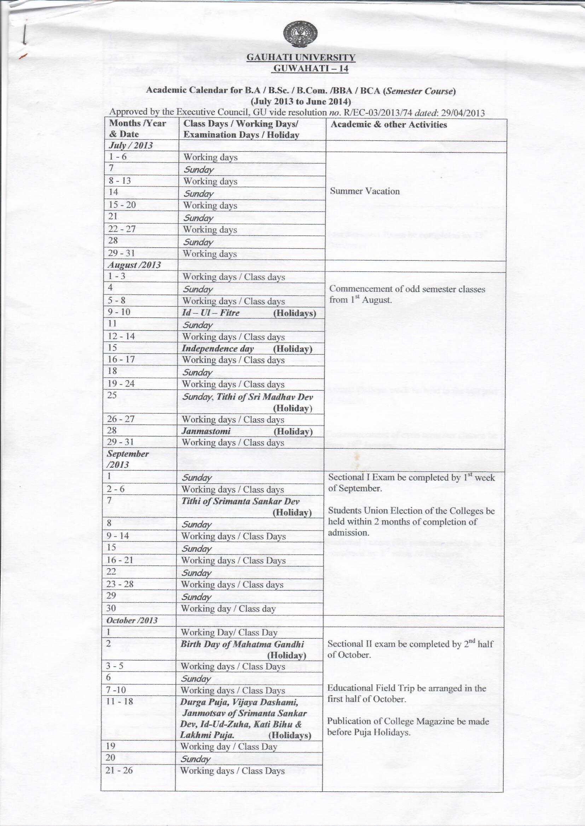

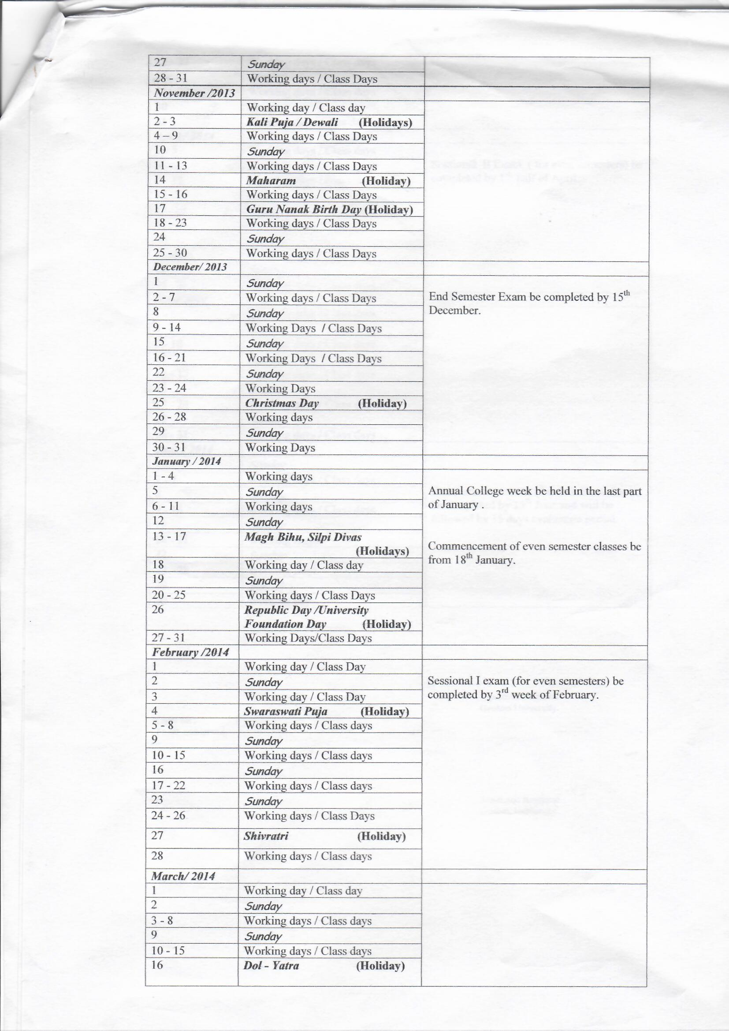

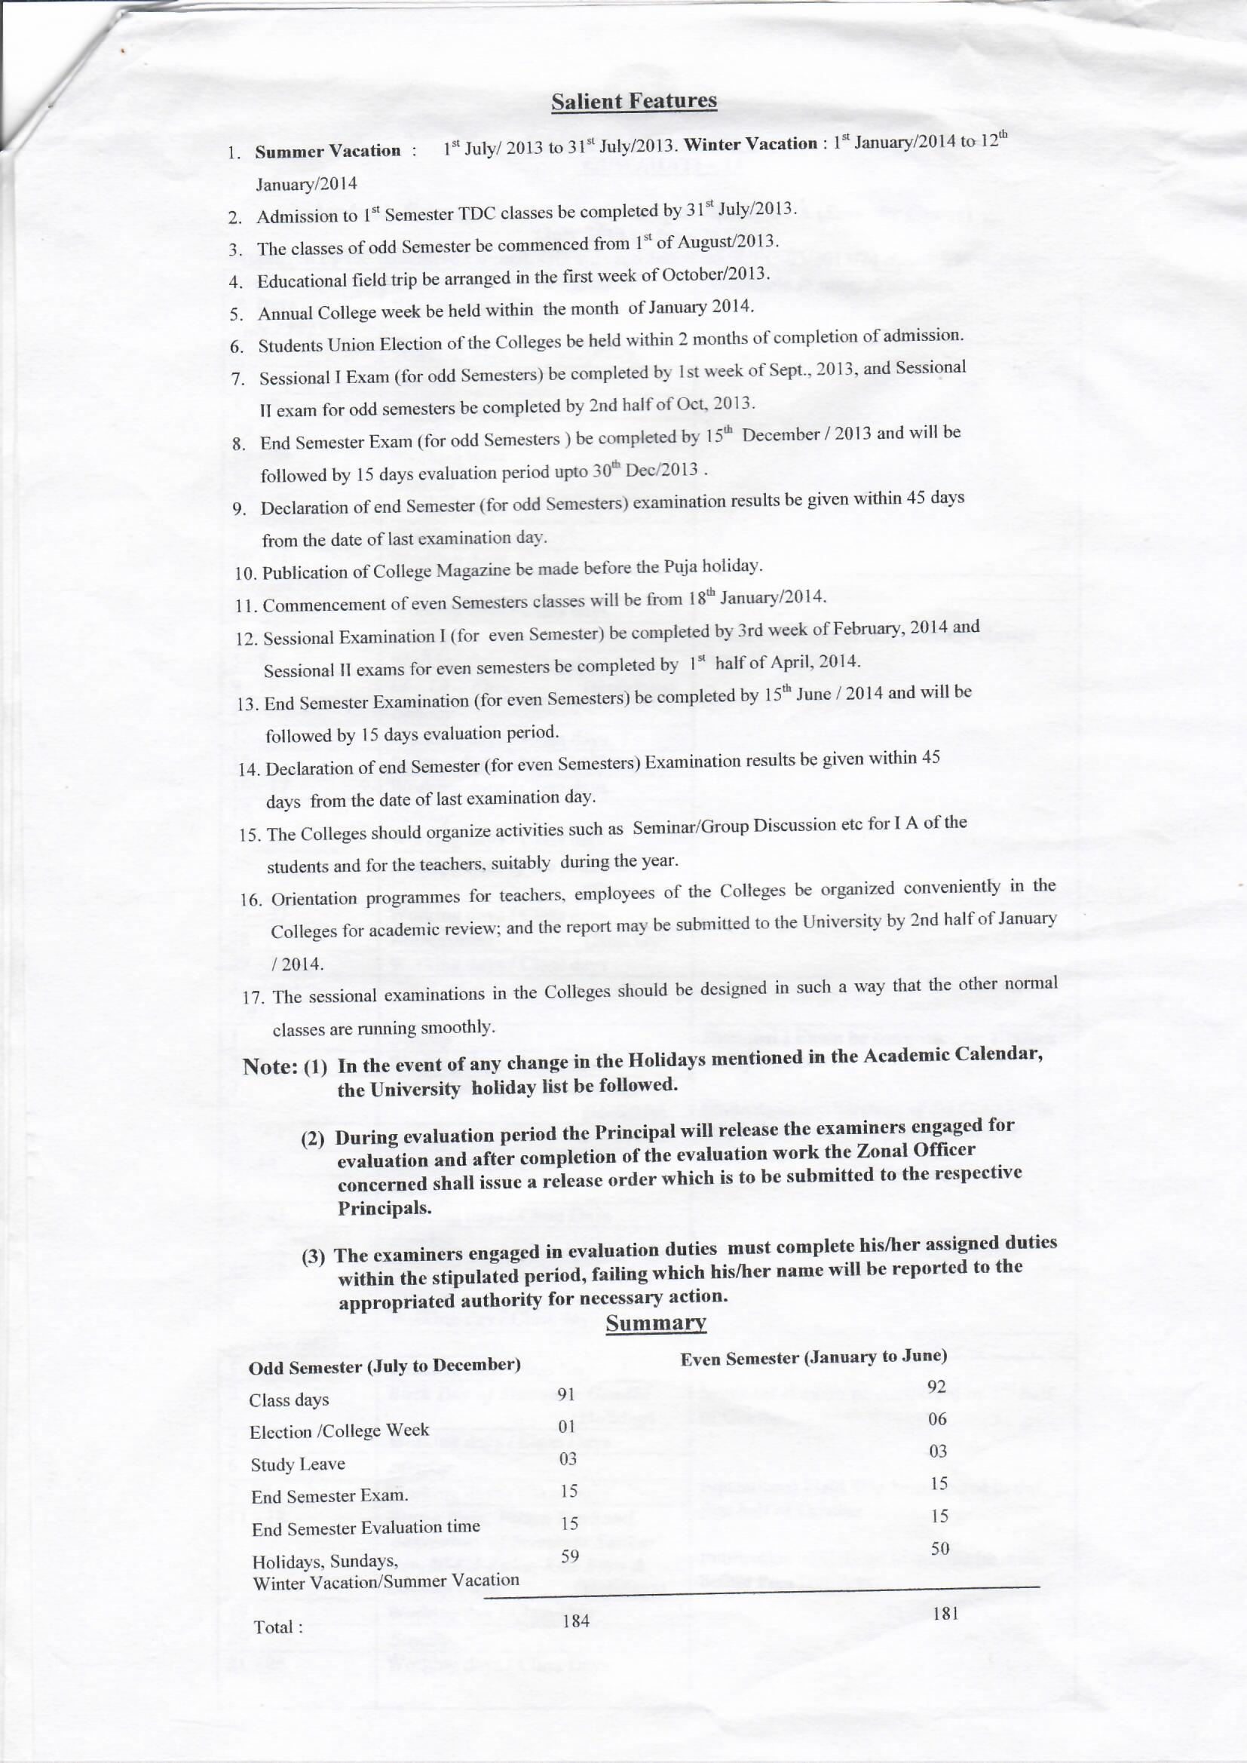
Annexure III
Graphical Representation of Student Feedback

DEPARTMENT OF ENGLISH
 | NR Mishra | M Barthakur | Runjun Devi | Rupa R Bhuyan
Communication Skill | 8.2 | 8.9 | 9.42 | 0
Interest generated by Teacher | 8.1 | 8.9 | 8.9 | 0
Ability to integrate Course | 8.1 | 9.67 | 8.7 | 0
Ability to integrate other Course | 8.2 | 8.9 | 8.77 | 0
Accessibility of the teacher | 8.1 | 8.67 | 9.1 | 0
Ability to design exam | 8.3 | 9 | 8.56 | 0
Providing feedback | 7.98 | 9.1 | 9 | 0
Knowledge of teacher | 8.55 | 9.6 | 9.34 | 0
Sincerity of teacher | 8.98 | 9.7 | 9.7 | 0
Overall rating | 8.78 | 9.6 | 9.8 | 0

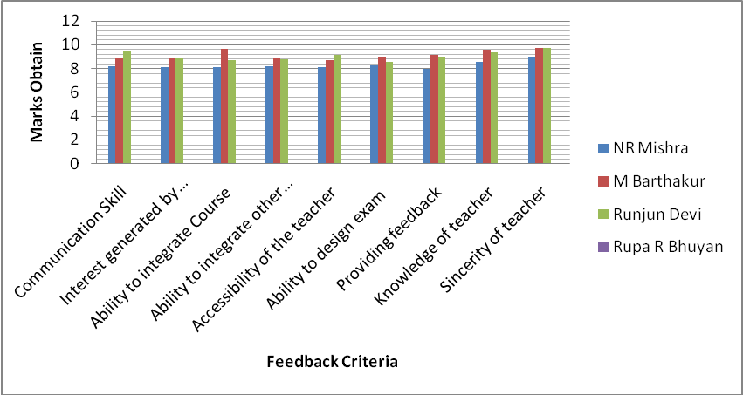

DEPARTMENT OF SANSKRIT
 | Gagen Kakati | Aparna Devi
Communication Skill | 9.1 | 9
Interest generated by Teacher | 9 | 9.09
Ability to integrate Course | 8.99 | 9.87
Ability to integrate other Course | 9.45 | 9.5
Accessibility of the teacher | 8.98 | 9.97
Ability to design exam | 9.23 | 9.45
Providing feedback | 9.65 | 9.8
Knowledge of teacher | 9 | 9.7
Sincerity of teacher | 9.4 | 9.3
Overall rating | 9.5 | 9.89

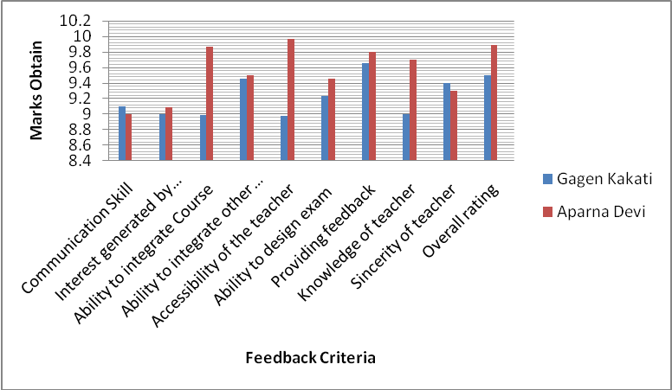

DEPARTMENT OF ARABIC
 | Jamaluddin Ahmed | Aser Uddin | Abdul Qasem
Communication Skill | 8.78 | 9 | 9
Interest generated by Teacher | 9.34 | 9.45 | 8.9
Ability to integrate Course | 9.87 | 8.45 | 8.78
Ability to integrate other Course | 9.84 | 8.87 | 9.4
Accessibility of the teacher | 9.12 | 8.9 | 9.87
Ability to design exam | 9.9 | 9.89 | 9.34
Providing feedback | 8.99 | 8.98 | 9.89
Knowledge of teacher | 9.78 | 9.05 | 8.2
Sincerity of teacher | 9.67 | 9.78 | 9.78
Overall rating | 9.79 | 9.7 | 9.56

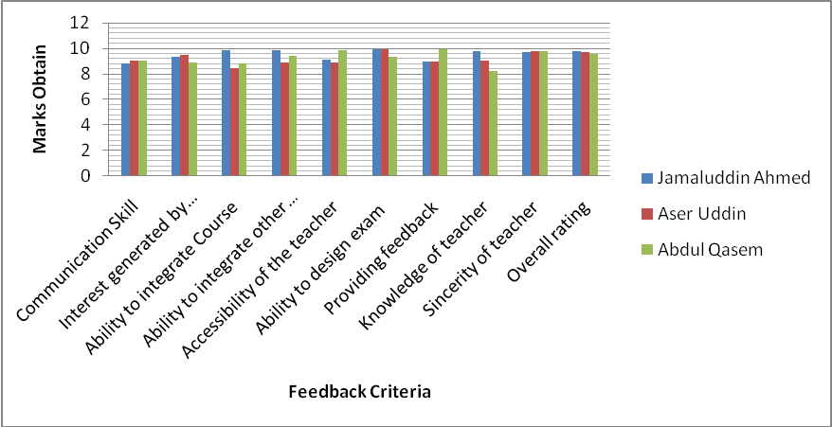

DEPARTMENT OF ECONOMICS
 | Paresh Sarma | Umesh Sarma | Chandana Goswami | Santosh Borkakoti
Communication Skill | 8.9 | 9.4 | 9 | 9.1
Interest generated by Teacher | 8.45 | 9.3 | 9 | 9.99
Ability to integrate Course | 8.98 | 9.5 | 9.9 | 9.98
Ability to integrate other Course | 9.54 | 9.43 | 9.98 | 8.98
Accessibility of the teacher | 9.98 | 9.54 | 9.99 | 9.3
Ability to design exam | 9.3 | 8.9 | 9.99 | 9.4
Providing feedback | 9.5 | 8.87 | 9.46 | 9.43
Knowledge of teacher | 9.9 | 9.34 | 9.45 | 9.43
Sincerity of teacher | 9.45 | 9.6 | 9.89 | 9.03
Overall rating | 9.54 | 8.78 | 9.99 | 9

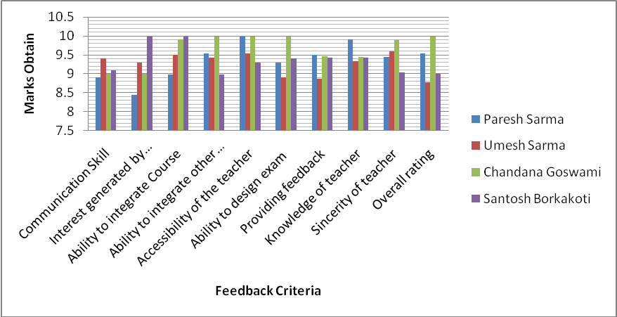

DEPARTMENT OF BOTANY
 | Kamud Sarma | Plabita Patowari | Khagen Nath | Pratibha Deka | Sahabuddin Ahmed | Sachin Saharia
Communication Skill | 0 | 8.9 | 0 | 9.12 | 9.45 | 8.9
Interest generated by Teacher | 0 | 9.8 | 0 | 8.8 | 9.65 | 6
Ability to integrate Course | 0 | 9.34 | 0 | 8.9 | 9.7 | 8.4
Ability to integrate other Course | 0 | 9.2 | 0 | 8.67 | 8.5 | 9
Accessibility of the teacher | 0 | 9.89 | 0 | 9.99 | 9.54 | 8.4
Ability to design exam | 0 | 9.7 | 0 | 8.98 | 9.76 | 9.34
Providing feedback | 0 | 9.54 | 0 | 9.87 | 9.04 | 8.76
Knowledge of teacher | 0 | 9.6 | 0 | 9.78 | 9.12 | 7.56
Sincerity of teacher | 0 | 9.93 | 0 | 9.66 | 9.45 | 7.98
Overall rating | 0 | 9.45 | 0 | 9.3 | 9.78 | 8.34

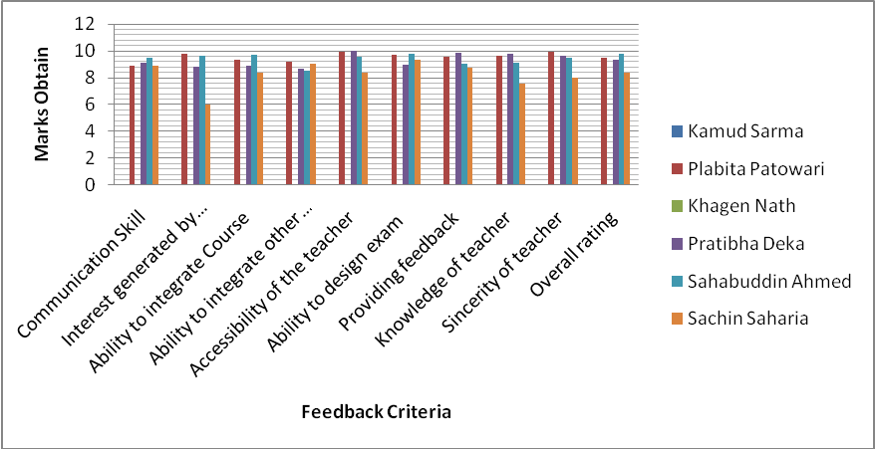

DEPARTMENT OF MATHAMATICS
 | Prafulla Borah | Debajit Nath | Dimbeswar Kalita | Jyotismita Kalita
Communication Skill | 9.9 | 9.65 | 9.34 | 9..99
Interest generated by Teacher | 9.6 | 9.34 | 9.56 | 9.78
Ability to integrate Course | 9.21 | 8.9 | 9.7 | 8.92
Ability to integrate other Course | 8.98 | 9.32 | 9.65 | 8.09
Accessibility of the teacher | 8.98 | 9.7 | 9.56 | 9.88
Ability to design exam | 9.78 | 9.09 | 8.56 | 9.78
Providing feedback | 9.87 | 9.6 | 8.54 | 8.34
Knowledge of teacher | 9.56 | 9.56 | 8.67 | 8.78
Sincerity of teacher | 9.45 | 7.56 | 8.78 | 8.56
Overall rating | 9.34 | 8.9 | 8.9 | 8.98

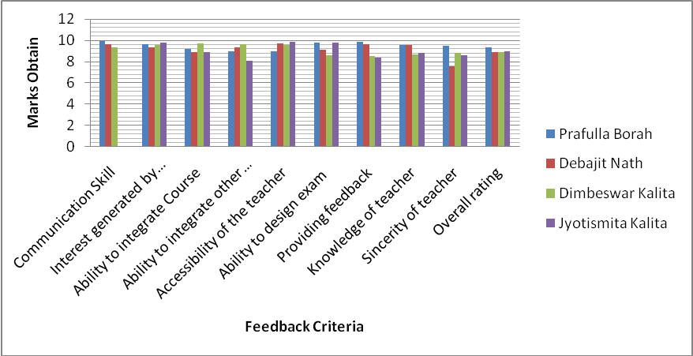

DEPARTMENT OF PHILISOPHY
 | Prabin Baruah | Bhupen Haloi | Manju Kalita | Nabajyoti Dolai
Communication Skill | 9.96 | 9.34 | 8.93 | 8.9
Interest generated by Teacher | 9.7 | 9.5 | 8.98 | 9.99
Ability to integrate Course | 9.6 | 9.43 | 8.99 | 9.6
Ability to integrate other Course | 9.8 | 9.7 | 9.54 | 9.7
Accessibility of the teacher | 8.6 | 9.1 | 9.45 | 9.5
Ability to design exam | 9.69 | 9.2 | 8.2 | 9.9
Providing feedback | 9.56 | 8.9 | 8.2 | 9.9
Knowledge of teacher | 9.98 | 9.5 | 8.11 | 9.8
Sincerity of teacher | 9.67 | 9.56 | 8.3 | 8.21
Overall rating | 9 | 9.5 | 8.12 | 8.34

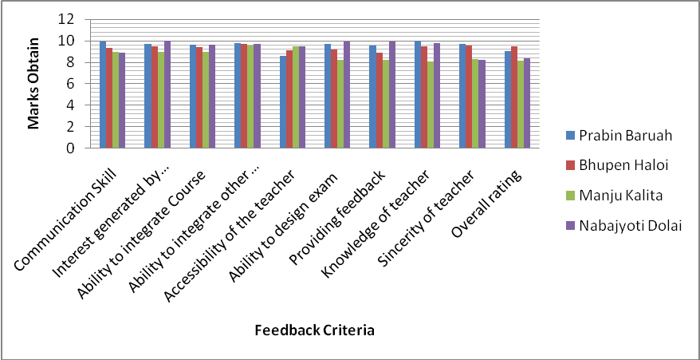

DEPARTMENT OF EDUCATION
 | Babita Sarma | Kunjalata Baruah | Usha Rani Deka
Communication Skill | 9.88 | 9.98 | 9.2
Interest generated by Teacher | 9.4 | 9.3 | 9.5
Ability to integrate Course | 8.34 | 9 | 8.9
Ability to integrate other Course | 9.78 | 9.67 | 8.56
Accessibility of the teacher | 9.45 | 9.34 | 8.3
Ability to design exam | 9.9 | 9.4 | 8.67
Providing feedback | 9.1 | 9.65 | 8.45
Knowledge of teacher | 9.34 | 9.83 | 8.54
Sincerity of teacher | 9.6 | 9.82 | 9.23
Overall rating | 9.45 | 9.78 | 7.05

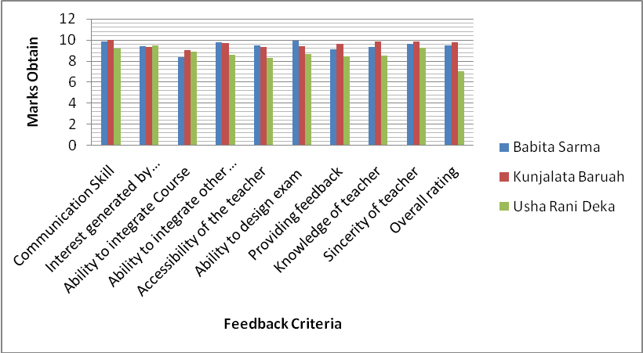

DEPARTMENT OF GEOGRAPHY
 | Moti Ram Medhi | Hariman Deka | Pabitra Nath | Mukut Sarma | Jayanta Baruah | Pranjit Kr. Sarma
Communication Skill | 9.98 | 9 | 9.9 | 9.6 | 8.4 | 9.82
Interest generated by Teacher | 9.56 | 8 | 9.7 | 8.5 | 8.5 | 9.76
Ability to integrate Course | 8.96 | 9.58 | 9.45 | 8.99 | 9.95 | 9.89
Ability to integrate other Course | 8.78 | 9.34 | 9.8 | 9.89 | 8.27 | 9.59
Accessibility of the teacher | 8.93 | 8.67 | 9.12 | 9.04 | 8.9 | 9.93
Ability to design exam | 9 | 8.23 | 9.5 | 9.98 | 9.34 | 9.78
Providing feedback | 9.2 | 8.94 | 9.56 | 9.78 | 9.5 | 9.78
Knowledge of teacher | 8.7 | 8.55 | 8.98 | 9.2 | 7 | 9.98
Sincerity of teacher | 9.7 | 9.76 | 9.34 | 9.12 | 8 | 9.87
Overall rating | 9 | 9.34 | 9.34 | 9 | 8.9 | 9.89

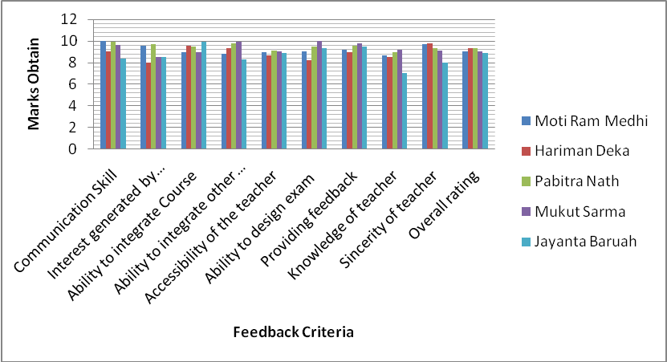

 | DEPARTMENT OF PHYSICS
 | Narayan Mudoi | Bandana Goswami | Kankan Sarma | Ranjan Sarma | Bhabesh Choudhury
Communication Skill | 0 | 0 | 8 | 9.7 | 8.5
Interest generated by Teacher | 0 | 0 | 7.9 | 9.78 | 8.4
Ability to integrate Course | 0 | 0 | 9.5 | 5.98 | 9.3
Ability to integrate other Course | 0 | 0 | 8.5 | 9.56 | 8.3
Accessibility of the teacher | 0 | 0 | 9.34 | 9.43 | 9.4
Ability to design exam | 0 | 0 | 8.5 | 9.65 | 8.12
Providing feedback | 0 | 0 | 8.3 | 9.6 | 9.5
Knowledge of teacher | 0 | 0 | 8.4 | 9.3 | 7.34
Sincerity of teacher | 0 | 0 | 8.7 | 8.3 | 9.45
Overall rating | 0 | 0 | 8.5 | 8.5 | 7.54

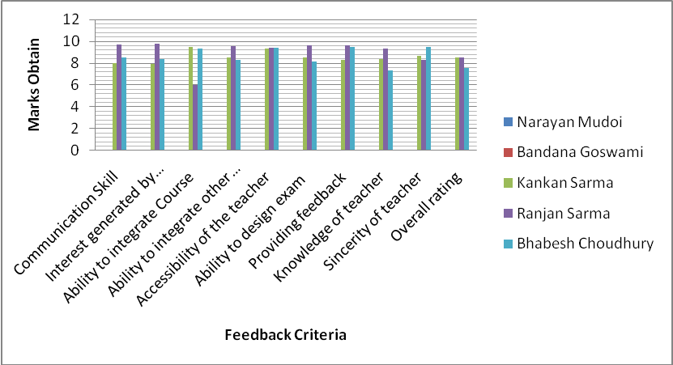

 | DEPARTMENT OF ZOOLOGY
 | Ranu Kalita | Budhin Hazarika | Pranab Sarma | Minati Sarma | Dipa Mishra | Leena Saikia | Seemajyoti
Communication Skill | 9.1 | 0 | 9.4 | 9.6 | 8.8 | 8.4 | 8.78
Interest generated by Teacher | 8.78 | 0 | 7.3 | 8.9 | 8.76 | 8.76 | 7.99
Ability to integrate Course | 8.45 | 0 | 9.6 | 8.5 | 8.97 | 8.76 | 9.98
Ability to integrate other Course | 8.7 | 0 | 9.12 | 8.54 | 9.56 | 8.56 | 9.7
Accessibility of the teacher | 8.54 | 0 | 9.76 | 8.76 | 8.56 | 8.86 | 9.8
Ability to design exam | 8.56 | 0 | 9.6 | 8.87 | 7.9 | 8.54 | 8.3
Providing feedback | 8.95 | 0 | 9.5 | 9.87 | 8.23 | 8.45 | 9.12
Knowledge of teacher | 9.6 | 0 | 9.43 | 9.87 | 8.54 | 8.6 | 8.7
Sincerity of teacher | 8.65 | 0 | 9.5 | 8.54 | 8.5 | 8.76 | 8.1
Overall rating | 8.23 | 0 | 8.5 | 8.78 | 9.54 | 8.44 | 8.54

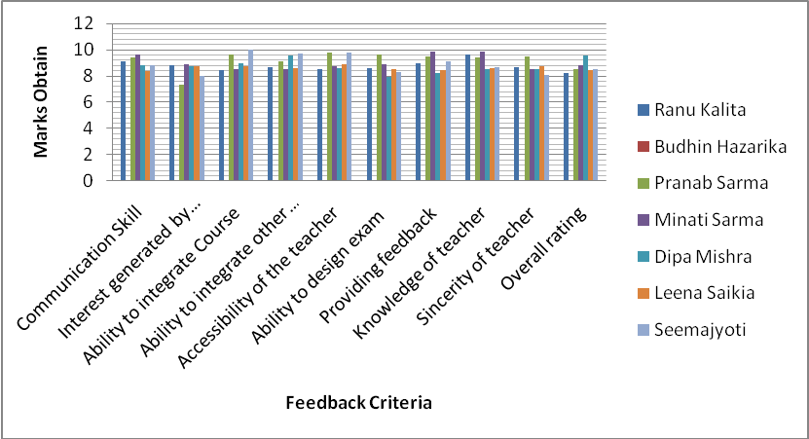

DEPARTMENT OF POLITICAL SCIENCE
 | Issaram Nath | Barnali Deka | AnupamThakuria
Communication Skill | 9.78 | 8.56 | 8.7
Interest generated by Teacher | 9.98 | 8.5 | 9.7
Ability to integrate Course | 9.43 | 8.7 | 9.83
Ability to integrate other Course | 9.31 | 7.9 | 9.71
Accessibility of the teacher | 9.67 | 8.88 | 9.06
Ability to design exam | 9.67 | 8.6 | 9.87
Providing feedback | 9.89 | 8.4 | 9.76
Knowledge of teacher | 9.87 | 9.8 | 9.79
Sincerity of teacher | 9.78 | 9.6 | 9.64
Overall rating | 9.51 | 9.65 | 9.45

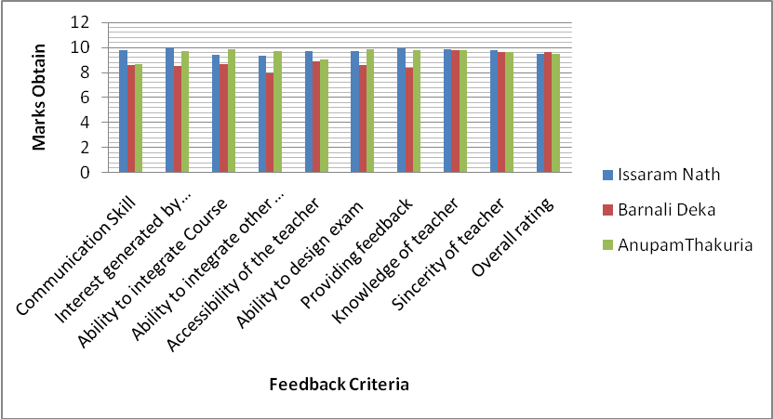

DEPARTMENT OF HISTORY
 | Sangita Gogoi | Angiras | Mridul Deka | Dhrubajyoti Sarmah
Communication Skill | 0 | 9.89 | 9 | 9.7
Interest generated by Teacher | 0 | 9.87 | 9.87 | 9.7
Ability to integrate Course | 0 | 9.83 | 9.76 | 8.23
Ability to integrate other Course | 0 | 9.76 | 9.56 | 7
Accessibility of the teacher | 0 | 9 | 9.32 | 7.32
Ability to design exam | 0 | 9.67 | 9.34 | 7.9
Providing feedback | 0 | 9 | 9.45 | 7.3
Knowledge of teacher | 0 | 8 | 9.67 | 8.09
Sincerity of teacher | 0 | 9.4 | 9.4 | 8.6
Overall rating | 0 | 9.6 | 9.5 | 8.5

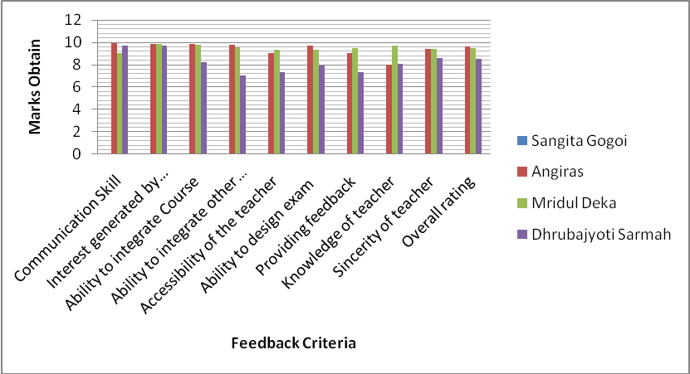

DEPARTMENT OF ASSAMESE
 | Dimbeswar Baruah | Rupjyoti Baruah | RS | JP | SPD | Bijoy Kumar Sarma | BK
Communication Skill | 9 | 9.2 | 9.6 | 8.65 | 9.54 | 9.5 | 8.3
Interest generated by Teacher | 8.9 | 9.7 | 8.6 | 9.54 | 9.65 | 8.99 | 7.09
Ability to integrate Course | 9.3 | 9 | 8.67 | 9.87 | 8.45 | 9 | 8.3
Ability to integrate other Course | 8.9 | 8.3 | 9.5 | 8.67 | 9.8 | 9.4 | 9
Accessibility of the teacher | 9.4 | 8.6 | 8.9 | 9.78 | 9.89 | 9.2 | 8.09
Ability to design exam | 9.1 | 8.4 | 8.65 | 7.9 | 9.99 | 8.34 | 7.45
Providing feedback | 9 | 8.6 | 9.7 | 8.9 | 8.8 | 7.34 | 8.09
Knowledge of teacher | 8.4 | 8.6 | 8.34 | 8.5 | 8.98 | 9.34 | 7.09
Sincerity of teacher | 8.9 | 8.2 | 7.5 | 8.67 | 9.8 | 8.34 | 9
Overall rating | 7.8 | 8.76 | 8.34 | 8.23 | 8.5 | 9.89 | 8.9

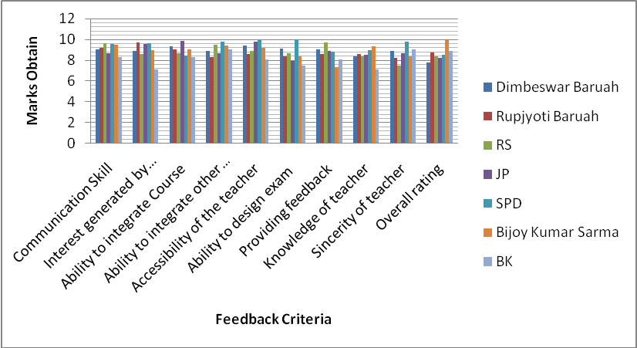

DEPARTMENT OF STATISTICS
 | Punnya Sarma | Ramesh Sarma | Ranjita Goswami | Pranab Das
Communication Skill | 0 | 4 | 8 | 9
Interest generated by Teacher | 0 | 8 | 6 | 5
Ability to integrate Course | 0 | 6 | 7 | 7
Ability to integrate other Course | 0 | 4 | 9 | 4
Accessibility of the teacher | 0 | 3 | 8 | 9
Ability to design exam | 0 | 2 | 7 | 8.8
Providing feedback | 0 | 3 | 8 | 7
Knowledge of teacher | 0 | 4 | 5 | 9
Sincerity of teacher | 0 | 3 | 8 | 7
Overall rating | 0 | 4.2 | 7.5 | 8

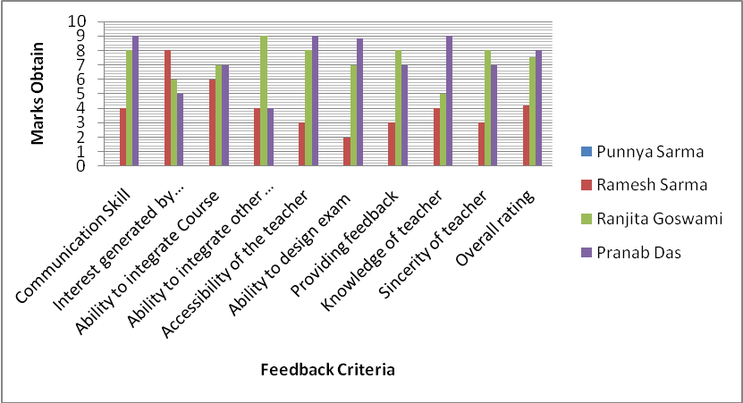

 | DEPARTMENT OF CHEMESTRY
 | Atul Prashad Sikdar | Pankaj Ghose | Dipali Saharia | Niranjan Sarma | Kamala Borah | Nasser Ul Islam
Communication Skill | 9.9 | 9.3 | 7.3 | 7.4 | 8.23 | 7.23
Interest generated by Teacher | 9.7 | 9.6 | 9 | 9.69 | 9.4 | 8
Ability to integrate Course | 9.89 | 9.8 | 9.89 | 7 | 9.3 | 9
Ability to integrate other Course | 9.89 | 9.9 | 8 | 8.67 | 8 | 8.45
Accessibility of the teacher | 9.99 | 9.89 | 8 | 8 | 8 | 9.34
Ability to design exam | 9.99 | 9.8 | 9.6 | 8.9 | 9.6 | 9.84
Providing feedback | 9.67 | 9.8 | 8 | 9 | 6 | 7
Knowledge of teacher | 9.89 | 9.78 | 7 | 8.4 | 9.89 | 7.77
Sincerity of teacher | 9.93 | 9.67 | 6 | 8.1 | 6 | 6.98
Overall rating | 9.9 | 9..9 | 8 | 7 | 8.76 | 8

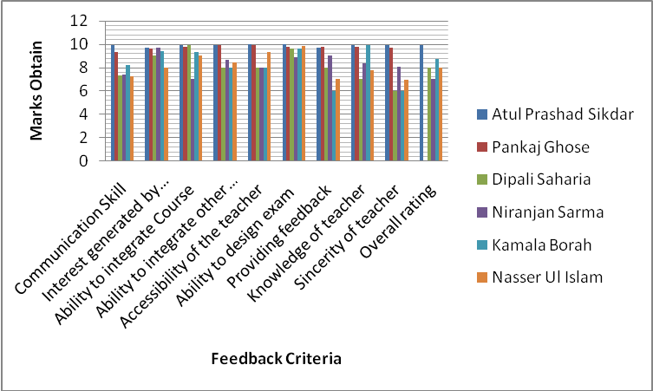

Annexure IV
Best Practice-1
- Title: “Ex-situ conservation of Rare, Endangered and Threatened (RET) and local fruit plants of Assam in Botanical garden of Mangaldai College”
- Goal: The natural resources of Assam have been depleting fast during the last few decades due to some anthropogenic activities and natural calamities. The aim of the practice is to conserve the RET plants and local fruit plants of Assam. It is expected that the practice will create great interest among students towards conservation, education, awareness, research and sustainable development of plant diversity with scope of acquiring traditional knowledge. It is also expected that the college shall be able to establish a healthy gene bank of RET plants and local fruit plants of Assam.
- Context: In ancient India, people were dependent on forest resources in the ambient areas with a variety of tradition in relation to conservation pattern. Wild fruits also provide an important source of food for mankind from the dawn of civilization. Rural people were dependent on these fruits. The valuable information on utility and choice of wild species of fruits were passed from generation to generation. Indigenous fruits play an important role in the lives of rural community, but gradually the rural population is now dependent heavily on resources of forest of ambient area. If the current human interference and other casual factors are continue to operate, the days are not far when these plants will vanish forever from their natural dwelling. Therefore, depletion of natural resources at a fast rate challenges the world scientists to conserve our nature, wild life and the socio-cultural atmosphere of inhabitants in a sustainable manner. So, a glimpse of nature conservation and biodiversity can be obtained through such efforts.
- The Practice: Due to increase in population, urbanisation, destruction of habitat, many plant species have been facing for extinction, threatened and endangered condition. Attempts have been made to conserve the RET plants and local fruit plants species in the college campus. This practice pertains to assess wild edible fruits and RET plants of Assam and accordingly we collected published reference materials. We have use Meta analysis to search for such plants of Assam. As our starting point, we have collect some RET plants and local fruit plants from various sources and natural habitats involving students, teacher, non-teaching employers and nature lovers, and planted them in our college campus. Required maintenance and protections also provided. Awareness programmes are arranged time to time among students, teachers and neighbouring people.
Due to the various disturbances there has been the loss of great number of plant species including several unique and irreplaceable varieties, while many more are awaiting a similar rate. It is estimated that there are more than
2, 70,000 plant species in existence and about 34,000 are endangered. In India about 15-20% plant species are considered to be threatened. North-East India is experiencing an alarming rate of deforestation and degradation, causing threat to the world’s well known hot spot. Ex-situ conservation used to safeguard populations in danger of destruction, replacement and deterioration. Approaches to ex-situ conservation include methods like seed storage, DNA storage, pollen storage, in vitro conservation, field gene banks and botanical gardens which are considered as useful in the field of Indian higher education.
- Evidence of successes:
- This practice has increased the number of trees in the college campus and has enhanced the quality of the environment.
- This practice has helped to conserve the local fruit plants which are becoming rare.
- This practice has made these plants familiar to the students and the local population. They have become interested in the project and have started to contribute sapling of these plants to the college.
- Problems encountered and resources required: We have been facing some problems of financial shortages, human and cattle disturbances for biodiversity conservation. We tried to overcome the problems faced for the attempts. The cattle, animals from the neighbouring areas enter the campus by which the plantation is disturbed seriously. It would be noteworthy that the college has a land of area 33.56 acres, due to which we have huge scope to make the practice success. But for protection of the planted species fencings are required. In addition, extra care should be employed for nurturing and caring the plant species. In conclusion it may be mentioned that if we get more financial assistance then practice will be more fruitful and meaningful.
- Note : The practice leads to a botanical garden which is of immense value not only to botanists, horticulturalists, home gardeners, landscape gardeners but also to persons of other fields, tourists and common people where they have the facilities of lectures and demonstrations to meet the needs and interests of individuals. As this practice has immense institutional value for creating environmental awareness, and as a model of sustainability, it is suggestive and relevant for adopting this practice in other higher educational institutions having science stream with sufficient land area.
Contact Details :
Name of the Principal : Dr. Khagendra Kumar Nath
Name of the Institution : Mangaldai College
City : Mangaldai
Pin Code : 784 125
Accredited Status : C⁺⁺ (2004)
Work Phone : 03713-230036 Fax : 03713-230036
Website : mangaldaicollege.org E-mail : principalnath@gamil.com
Mobile : 094351 85896
Annexure V
Best Practice-2

- Title of the Practice : Introduction of Assisted Group Learning (AGL) on a Pilot
Basis in Chemistry Department
- Goal : The lack of interest in traditional classroom is considered to be one of the behavioural changes of undergraduate chemistry students. This can be eliminated to some extent by playing a vital role by the teachers in bringing some innovation in teaching-learning process. Assisted Group Learning (AGL) is a model devised on the basis of POGIL (Process Oriented Guided Inquiry Learning) which engages all the students of the class in learning process with great deal of interest.
- The Context : POGIL (Process Oriented Guided Inquiry Learning) is a pedagogical method devised to teach process skills (such as collaboration and written expression) as well as content using an inquiry based education approach. It was originally devised by professors at Franklin and Marshall College and the State University of New York, Stony Brook for use in teaching general chemistry, but the structure of POGIL is broadly applicable in all subjects.
In a POGIL classroom, students work together in groups of 3 or 4. Each student is assigned a role, such as manager, recorder, spokesperson or reflector. The students work together on activities that are structured to help them build up a concept. The students are expected to reach a consensus answer to each question on the activity, then be able to communicate that answer in written or oral form. This group structure creates positive interdependence among the students, reinforcing involvement and learning for each student. Innovations and reforms in Chemistry teaching-learning on the basis of POGIL have been taken up in the Department of Chemistry, Mangaldai College, Assam. Assisted Group Learning (AGL) is one of models developed for effective learning in Chemistry.
- The Practice : In this model, a group of four undergraduate students is constructed to solve a problem (numerical) and to write reaction mechanism in Chemistry. One of the member of the group acts as the leader and others as facilitator, recorder and reporter. A problem-sheet/mechanism-sheet containing the detailed analysis of the problem/numerical/mechanism is given to the group to study and asked to solve the problem in the reverse page of the sheet under the constant guidance of a teacher. The whole class may be divided into several groups of 4 members each and given different problems/mechanism to each group. When the 1st problem/mechanism for each group is finished, the groups are reconstructed either by introducing new members from the other group or by reshuffling the designation of the members of the old group and then the problem sheets are redistributed such that all group get a new problem. Thus, the model involves all the students of the class in learning process.
The advantages of this model are (1) knowing the tastes and fruits of group learning, (2) knowing the way of sharing knowledge with colleagues and teachers, (3) knowing the colleagues in better way, and finally (4) developing their analytical skill in problem solving and removing fears to solve problem/numerical and to write mechanism of reaction in Chemistry.
- Evidences of Success :
The following are the evidences of success for this model-
- Increase in percentage of attendance in classroom.
- Quite encouraging response from the learner as they demand AGL classes frequently.
- Increase in percentage of marks in Physical and Organic Chemistry paper in the final B.Sc. examination.
Thus Assisted Group Learning (AGL) is a model developed to generate interest among the undergraduate students in learning Chemistry in traditional classroom under constant guidance of teacher. The evidence of success clearly indicates that this model can be applied in all other subjects. This model will definitely be helpful in generating interest of students in classroom.
- Problems Encountered and Resources Required :
The following are the problems encountered in this model :
- The operation of the model requires a hall where proper and comfortable sitting arrangement for the groups can be made.
- The model requires whole day of class and hence it is operative once a week.
- The model is difficult to run in a traditional class room without any digital teaching aids.
Contact Details :
Name of the Principal : Dr. Khagendra Kumar Nath
Name of the Institution : Mangaldai College
City : Mangaldai
Pin Code : 784 125
Accredited Status : C⁺⁺ (2004)
Work Phone : 03713-230036 Fax : 03713-230036
Website : mangaldaicollege.org E-mail : principalnath@gamil.com
Mobile : 094351 85896
Annexure VI
SWOT Analysis

S :
- A spacious green campus of 33.56 acres of land with potentiality for future requirement.
- Qualified teaching staff with 20 Ph.D. degree holders.
- Inclusive and high enrolment of students.
- Low dropout rate.
- Establishment of Institutional Level Biotech Hub sponsored by DBT, for improvement of research activity.
- Well equipped digital Science Gallery for seminar/conference/workshop.
W :
- Lack of PG courses and other career oriented courses.
- No formal feed-back from alumni and parents.
- Delay in filling up the vacancies of teaching and non-teaching posts due to long Government procedures.
- Incomplete boundary wall.
- Inability to obtain more major research grant.
- Limited research publications by the faculty.
- Nominal participation of students in State/National/International events.
- Low frequency of extension activities.
- Shortage of adequate infrastructure and teaching staff to meet the burgeoning demand for enrolment.
- Slow technology up-gradation.
- Limited student counselling.
- Limited industry interaction/collaboration.
- No significant activities and support from alumni.
- No formal parent-teacher association.
O :
- Scope for opening of PG courses in Botany, Chemistry, Physics, Geography and Zoology in a phased manner.
- Formation of alumni association for feed-back, suggestion and support in various activities of the College.
- Establishment of Biotech Hub encourages the science faculty members to be involved in writing proposals for major research project to UGC/DBT/DST, etc.
- Scope for improvement of teaching-learning process on the feed-back obtained from the parent-teacher meets.
T :
- Delay in filling up of vacant posts of teaching and non-teaching staff.
- Non-creation of new teaching and non-teaching posts.
- Encroachment of College land by the neighbours due to incomplete structural barrier.
- Less steps taken to strengthen the programmes on career guidance, health check up and care and extension activities.
- Extra class load for the teachers for H.S. courses in U.G. Colleges.

