The Annual Quality Assurance Report (AQAR)

For the Year : 2015–16

Submitted to the

Director,
National Assessment and Accreditation Council
Bangalore – 560 010



By

Internal Quality Assurance Cell

Mangaldai College
Mangaldai – 784 125
Darrang (Assam), India
www.mangaldaicollege.org

2016

Contents

Forwarding from the Principal ...................................................................................................... 3
AQAR of IQAC for the year 2015–16 ..................................................................................... 4-62
Part – A : .................................................................................................................................. 4-10
- Details of the Institution ........................................................................................ 4
- IQAC Composition and Activities ........................................................................ 7
Part – B : ................................................................................................................................ 11-34
- Criterion – I : Curricular Aspects ........................................................................ 11
- Criterion – II : Teaching, Learning and Evaluation ............................................ 13
- Criterion – III : Research, Consultancy and Extension ....................................... 17
- Criterion – IV : Infrastructure and Learning Resources ...................................... 21
- Criterion – V : Student Support and Progression ................................................ 23
- Criterion – VI : Governance, Leadership and Management ................................ 27
- Criterion – VII : Innovations and Best Practices ..................................................32
- Plans of Institutiond for next year ....................................................................... 33
Annexures .............................................................................................................................. 34-62
Annexure I : Abbreviation ......................................................................................... 34
Annexure II : Academic Calendar ............................................................................. 35
Annexure III-A : Graphical Representation of Student Feedback on Courses ......... 38
Annexure III-B : Graphical Representation of Student Feedback on Teachers ........ 40
Annexure IV : Best Practice–1 .................................................................................. 56
Annexure V : Best Practice–2 ................................................................................... 59
Annexure VI : SWOT Analysis ..................................................................................61

OFFICE OF THE PRINCIPAL
MANGALDAI COLLEGE
MANGALDAI, ASSAM-784 125
Phone & Fax : 03713-230036, 094351 85896(M), e-mail : principalnath@gmail.com

Memo No. MC/2017/337 Dated Mangaldai the 27.11.2017

From: Dr. K. K. Nath, M.Sc. Ph.D. Principal,
Mangaldai College, Mangaldai

To
The Director
National Assessment and Accreditation Council
2/4, Dr. Raj Kumar Road, P.O. Box No. 1075, Rajajinagar
Bangalore – 560 010, India

Sub: Submission of “Annual Quality Assurance Report (AQAR)” for the session 2015-16.

Sir,
With reference to the subject cited above, I have the honour to submit herewith one copy of “Annual Quality Assurance Report (AQAR)” of Mangaldai College, prepared by the Internal Quality Assurance Cell (IQAC) for the academic session 2015-16. The report has been prepared as per instruction of NAAC to detail the tangible results achieved in key areas, specially identified by the institutional IQAC at the beginning of the academic year. The AQAR details the results of the perspective plan worked out by the IQAC.
This is for favour of your perusal and necessary action.
Thanking you.

Sincerely, yours



(Dr. K.K.Nath)
Principal,
Mangaldai College, Mangaldai.

The Annual Quality Assurance Report (AQAR) of the IQAC

Part – A

1. Details of the Institution
MANGALDAI COLLEGE
1.1 Name of the Institution
Vill.: Upahupara
1.2 Address Line 1
Mangaldai

Address Line 2
Mangaldai
City/Town
Assam
State
784 125
Pin Code
principalnath@gmail.com
Institution e-mail address
+919435185896
Contact Nos.
Dr. Khagendra Kumar Nath
Name of the Head of the Institution:
03713-230036
Tel. No. with STD Code:
+919435185896

Mobile:
Mr. Paresh Kumar Sarmah
Name of the IQAC Co-ordinator:

Mobile:
+919435006483
mciqac@gmail.com
IQAC e-mail address:

1.3 NAAC Track ID (For ex. MHCOGN 18879) : NIL
EC/32/A&A/255 dated 03-05-2004

1.4 NAAC Executive Committee No. & Date :
www.mangaldaicollege.org
1.5 Website address:
http://www.mangaldaicollege.org/AQAR,2015-16.doc
Web-link of the AQAR:

1.6 Accreditation Details
Sl. No. | Cycle | Grade | CGPA | Year of Accreditation | Validity Period
1 | 1st Cycle | C++ |  | 2004 | 2004 - 2009
2 | 2nd Cycle
3 | 3rd Cycle
4 | 4th Cycle

1.7 Date of Establishment of IQAC : DD/MM/YYYY
13/06/2005

2015-16
1.8 AQAR for the year (for example 2010-11)

1.9 Details of the previous year’s AQAR submitted to NAAC after the latest Assessment and Accreditation by NAAC ((for example AQAR 2010-11submitted to NAAC on 12-10-2011)
- AQAR 2014-15 (27/11/2017)
- AQAR 2013-14 (27/11/2017)
- AQAR 2012-13 (27/11/2017)
1.10 Institutional Status


University State Central Deemed Private


Affiliated College Yes No
Constituent College Yes No



Autonomous college of UGC Yes No





Regulatory Agency approved Institution Yes No
(eg. AICTE, BCI, MCI, PCI, NCI)


Type of Institution Co-education Men Women



Urban Rural Tribal





Financial Status Grant-in-aid UGC 2(f) UGC 12B

Grant-in-aid + Self Financing Totally Self-financing

1.11 Type of Faculty/Programme


Arts Science Commerce Law PEI (Phys Edu)



TEI (Edu) Engineering Health Science Management

Distance Education Programme under KKHSOU, IDOL.
H.S. Course under AHSEC.
Others (Specify)

1.12 Name of the Affiliating University (for the Colleges)
Gauhati University

1.13 Special status conferred by Central/ State Government-- UGC/CSIR/DST/DBT/ICMR etc

Autonomy by State/Central Govt. / University

University with Potential for Excellence UGC-CPE



DST Star Scheme UGC-CE

UGC-Special Assistance Programme DST-FIST

UGC-Innovative PG programmes Any other (Specify)

UGC-COP Programmes
2. IQAC Composition and Activities
06
2.1 No. of Teachers
00

2.2 No. of Administrative/Technical staff
00

2.3 No. of students
2.4 No. of Management representatives
00

00
2.5 No. of Alumni
2. 6 No. of any other stakeholder and
00

community representatives
00

2.7 No. of Employers/ Industrialists

2.8 No. of other External Experts
02

2.9 Total No. of members
03
]’
loiouyr
09

2.10 No. of IQAC meetings held
02

01

2.11 No. of meetings with various stakeholders: No. Faculty
01

00

00

Non-Teaching Staff Students Alumni Others



2.12 Has IQAC received any funding from UGC during the year? Yes No

If yes, mention the amount
2.13 Seminars and Conferences (only quality related)
(i) No. of Seminars/Conferences/ Workshops/Symposia organized by the IQAC
03

00

01

00

02

Total Nos. International National State Institution Level

(ii) Themes : IQAC extends the collaborative efforts in organizing the following quality related events :
Theme-1: A National Seminar on “Women Empowerment : Issues and Challenges”
Date : 11th and 12th September, 2015
No. of participants : 116
Theme-2 : A programme on “Familiarization and Applications of the equipments available in the Institutional Level Biotech Hub, Mangaldai College”
Date : 27th August, 2015
No. of participants : 96 (All B.Sc. freshers’ admitted in the session)
Theme-3 : A popular talk on “Bioresources of North-East India and Impact of Environmental Degradation”.
Date : 30th March, 2016
Resource Person : Dr. Prabodh Borah, Prof. Assam Agricultural University, Assam.
No. of Participants : 171

2.14 Significant Activities and contributions made by IQAC
a) Self appraisal report of individual teachers were collected by the IQAC to keep a record of the different activities of the faculty members.

b) Student Feedback on teachers were collected and analysed by the IQAC and submitted to the Principal for necessary action.
c) The IQAC encouraged the faculty members to take up project work and research activities through proper monitoring by the Research Committee formed recently.

d) The IQAC prepared a format for Teaching Plan, Daily Class Diary and Monthly Progress Report for every teacher to monitor the academic activities of every department.

2.15 Plan of Action by IQAC/Outcome
The plan of action chalked out by the IQAC in the beginning of the year towards quality
enhancement and the outcome achieved by the end of the year *
Plan of Action | Achievements
- Preparation and submission of the proposal for Bachelor of Vocation (B.Voc.) programme to the UGC. | - The UGC has sanctioned the proposal for B.Voc programme in two trades :  - Food Processing Technology  - Medical Lab and Molecular Diagnosis Technology.  The classes are started and two new Assistant Professors appointed on contractual basis.
- Initiative to introduce more skill-based courses in the College under DDUKY (Din Dayal Upadhaya Kushal Yojona). | 2. The proposal has been sent to the UGC.
- To construct new RCC building for the College Canteen. | 3. The construction work is going on.
- To shift the exam branch of the College to a permanent RCC building with a strong room and CCTV camera facility. | 4. Completed.
- To construct a resting shed for the students in a convenient place of the campus. | 5. Completed.
- To construct RCC buildings to shift the department of Mathematics, Statistics, English, Arabic, Philosophy and Krishna Kanta Handique State Open University study centre from the existing old Assam type constructions. | 6. Completed.
- To prepare a basket ball court in the campus to provide sporting facility to the students and staff. | 7. Completed.
- To shift the existing common room for girls to spacious and new RCC building with adequate convenience facility. | 8. Done.
- Proposal to generate resource for the College by opening a business outlet in the campus with availability of student items and Xerox facility. | 9. One business outlet opened.
- Continuation of the implementation of learning centric activities under DBT Star College Scheme. | 10. Partially implemented due to non release of 2nd Year grant by the DBT. The College continued the activities from its own resources.
- Preparation of proposal for a National Seminar to be organised by the Department of Chemistry. | 11. The Proposal entitled “Prospects and Challenges of Chemistry Education and Research Activities in the UG Colleges of Assam” was prepared and sent to the UGC for approval. The UGC sanctioned the proposal accordingly.
* Attach the Academic Calendar of the year as Annexure.
2.15 Whether the AQAR was placed in statutory body Yes No




Management Syndicate Any other body
Provide the details of the action taken
The management i.e. the Governing body of the college had authorized the Principal-cum-Chairperson of IQAC to take necessary action on plan of action chalked out by IQAC subject to the availability of funds.

Part – B
Criterion – I

1. Curricular Aspects

1.1 Details about Academic Programmes
Level of the Programme | Number of existing Programmes | Number of programmes added during the year | Number of self-financing programmes | Number of value added / Career Oriented programmes
PhD | 02 | 00 | 02 | 00
PG | 01 | 00 | 01 | 00
UG | 02 | 00 | 00 | 00
PG Diploma(PGDCA) | 01 | 00 | 01 | 00
Advanced Diploma | 00 | 00 | 00 | 00
Diploma(DOAEC) | 01 | 00 | 01 | 00
Certificate
Others (H.S.) | 02 | 00 | 00 | 00
Total | 09 | 00 | 05 | 00

Interdisciplinary | 00 | 01 (B.Voc.) (UG) | 00 | 01
Innovative

1.2 (i) Flexibility of the Curriculum: CBCS/Core/Elective option / Open options : Elective Option
(ii) Pattern of programmes:
Pattern | Number of programmes
Semester | 04
Trimester | 00
Annual | 01



1.3 Feedback from stakeholders* Alumni Parents Employers Students
(On all aspects)



Mode of feedback : Online Manual Co-operating schools (for PEI)
*Please provide an analysis of the feedback in the Annexure

1.4 Whether there is any revision/update of regulation or syllabi, if yes, mention their salient aspects.
No

1.5 Any new Department/Centre introduced during the year. If yes, give details.
- “Medical Lab Technology and Molecular Diagnostic” under UGC, B.Voc. programme.
- “Food Processing Technology” under UGC, B.Voc. programme.

Criterion – II
2. Teaching, Learning and Evaluation
2.1 Total No. of permanent faculty
Total | Asst. Professors | Associate Professors | Professors | Others
73 | 35 | 26 | 00 | 00
Note : 12 posts of Assistant Professor are vacant as on June, 2016
28
2.2 No. of permanent faculty with Ph.D.
Asst. Professors |  | Associate Professors |  | Professors |  | Others |  | Total
R | V | R | V | R | V | R | V | R | V
01 | 00 | 00 | 01 | 00 | 00 | 00 | 00 | 01 | 01
2.3 No. of Faculty Positions Recruited (R) and Vacant (V) during the year

00
00
00
2.4 No. of Guest and Visiting faculty and Temporary faculty

2.5 Faculty participation in conferences and symposia:

No. of Faculty | International level | National level | State level
Attended Seminars/ Workshops | 02 | 49 | 02
Presented papers | 01 | 28 | 01
Resource Persons | 00 | 01 | 00

2.6 Innovative processes adopted by the institution in Teaching and Learning:
The processes which were adopted by the institution in Teaching and Learning under DBT-STAR COLLEGE SCHEME in the last academic session 2015-16 are continued as detailed below :
- The classes and examination for the paper on Research Methodology for the 6th semester major students of Botany, Chemistry, Physics and Zoology department coming under the DBT-STAR COLLEGE SCHEME, have been continued. The objective of the paper is to orient and prepare the students to undertake the mandatory project work for the partial fulfilment of the award of degree of Bachelor of Science (B.Sc.) by the affiliating University and also to help them in future. The details of the paper are mentioned below:
Name of the paper : Research Methodology
Duration of course : 29-02-16 to 11-03-16
Date of Examination : 12-03-16
Full marks and Duration of Examination : 50 marks, 1 hour
Nature of Question Paper : MCQ = 40
: Very Short = 07
: Viva = 03
Level of Participants : 6th Semester Major Students.
Nos. of Participants : 78
- The 6th semester major students of Botany, Chemistry, Physics and Zoology were taken to the reputed Industry/Research institute like Kaziranga National Park, Bongaigaon Refinery & Petrochemical Ltd. (BRPL), Tezpur University and Pabitara Wild Life Sanctury & Rhino Breeding Project, Assam to provide access and exposure to the experimental science and advance learning. The details are mentioned below :
Sl. No. | Department | Place of visits | Date | No. of Participants
01 | Botany | Kaziranga National Park, Assam | 08/02/2016 | Teacher = 04  Student = 35  Total = 39
02. | Chemistry | Bongaigaon Refinery & Petrochemical Ltd. (BRPL), Assam | 29/01/2016 | Teacher = 01  Student = 27  Total = 28
03. | Physics | Tezpur University, Assam | 28/12/2015 | Teacher = 02  Student = 17  Total = 19
04. | Zoology | Pabitara Wild Life Sanctury & Rhino Breeding Project, Assam | 09/02/2016 | Teacher = 05  Student = 16  Total = 21
The programme will continue for the next academic session (2016-17)

2.7 Total No. of actual teaching days
172
during this academic year

2.8 Examination/ Evaluation Reforms initiated by
As per affiliating University guidelines
the Institution (for example: Open Book Examination, Bar Coding,
Double Valuation, Photocopy, Online Multiple Choice Questions)

2.9 No. of faculty members involved in curriculum
00
00
00
restructuring/revision/syllabus development
as member of Board of Study/Faculty/
Curriculum Development workshop

2.10 Average percentage of attendance of students
78%

2.11 Course/Programme wise
distribution of pass percentage :

Title of the Programme |  | Total no. of students appeared* | Division**
 |  | Total no. of students appeared* | Distinction % | I % | II % | III % | Pass %
BA | BA(M) | 285 |  |  |  |  | 91.57
BA | BA(G) | 275 |  |  |  |  | 65.10
B.Sc. | B.Sc.(M) | 94 |  |  |  |  | 75.50
 | B.Sc.(G) | 55 |  |  |  |  | 37.14
MA(Assamese) |  | 30 |  |  |  |  | 100.00
PGDCA |  | 47 |  |  |  |  | 17.02
MCA |  | 08 |  |  |  |  | 25.00
*Only regular final semester students are shown
** The affiliating university has stopped awarding classes from the year 2015-16.
2.12 How does IQAC Contribute/Monitor/Evaluate the Teaching & Learning processes :
a) The IQAC prepared a format for Teaching Plan, Daily Class Diary and Monthly Progress Report for every teacher to monitor the academic activities of every department.

b) The IQAC provides analysis of student feedback to the Principal and suggests the corrective measures to be adopted for better performance in the classroom by the teachers.

2.13 Initiatives undertaken towards faculty development
The college authority in consultation with IQAC provides study/duty leave to the faculty members/staff to attend the Faculty / Staff Development Programmes organised by various institution/bodies.
Faculty / Staff Development Programmes | Number of faculty  benefitted
Refresher courses | 09
UGC – Faculty Improvement Programme | 00
HRD programmes | 00
Orientation programmes | 01
Faculty exchange programme | 01
Staff training conducted by the university | 00
Staff training conducted by other institutions | 00
Summer / Winter schools, Workshops, etc. | 04
Others (Short Term Course) | 03

2.14 Details of Administrative and Technical staff
Category | Number of Permanent  Employees | Number of Vacant  Positions | Number of permanent positions filled during the Year | Number of positions filled temporarily
Administrative Staff | 29 | 08 | 00 | 04
Technical Staff | 00 | 00 | 00 | 00
Criterion – III
3. Research, Consultancy and Extension
3.1 Initiatives of the IQAC in Sensitizing/Promoting Research Climate in the institution
The initiatives of the last year (2014-15) are continued, i.e.

- The junior faculty members are encouraged to undertake Research Projects under various funding agencies. In this connection, the college authority in consultation with the IQAC and the Research Committee provides infrastructural facilities to the projects sanctioned by the funding agencies.

- The non Ph.D./M.Phil faculty members are encouraged to avail UGC-Faculty Development Programme for higher studies leading to Ph.D./M.Phil degrees.

- The Ph.D. faculty members are encouraged to write and publish books on the result/knowledge acquired through their research works.

- The faculty members and the science students are encouraged to utilize the facilities available in the newly established Institutional Level Biotech Hub in their research oriented project works.

- The major students of the Science departments are given smooth access to the well-equipped laboratory for their project work and advanced practical works.

3.2 Details regarding major projects
 | Completed | Ongoing | Sanctioned | Submitted
Number | 00 | 02 | 00 | 00
Outlay in Rs. Lakhs | 00 | 38.44 | 00 | 00

3.3 Details regarding minor projects
 | Completed | Ongoing | Sanctioned | Submitted
Number | 00 | 09 | - | 00
Outlay in Rs. Lakhs | 00 | 21.1 | - | 00

3.4 Details on research publications
 | International | National | Others
Peer Review Journals | 03 | 01 | 02 (State)
Non-Peer Review Journals | 00 | 00 | 00
e-Journals | 00 | 00 | 00
Conference proceedings | 01 | 08 | 02 (State)

3.5 Details on Impact factor of publications: N/A

Range Average h-index Nos. in SCOPUS

3.6 Research funds sanctioned and received from various funding agencies, industry and other organisations
Nature of the Project | Duration  Year | Name of the  funding Agency | Total grant  sanctioned | Received
Major projects | NIL | NIL | NIL | NIL
Minor Projects | 1.5 year | UGC | 21.1 lakh | 11.425 lakh
Interdisciplinary Projects | 3 years | DBT | 39.5 lakh | 5.66 lakh
Industry sponsored | NIL | NIL | NIL | NIL
Projects sponsored by the University/ College | NIL | NIL | NIL | NIL
Students research projects  (other than compulsory by the University) | NIL | NIL | NIL | NIL
Any other(Specify) | NIL | NIL | NIL | NIL
Total | - | - | 60.6 | 17.085

3.7 No. of books published i) With ISBN No. Chapters in Edited Books
05
00

00
ii) Without ISBN No.
3.8 No. of University Departments receiving funds from N/A
UGC-SAP CAS DST-FIST

DPE DBT Scheme/funds
3.9 For colleges Autonomy CPE DBT Star Scheme



INSPIRE CE Any Other (specify)

NIL
3.10 Revenue generated through consultancy
Level | International | National | State | University | College
Number | 00 | 01 | 00 | 00 | 02
Sponsoring agencies | - | UGC | - | - | DBT
3.11 No. of conferences organized by the Institution
01
3.12 No. of faculty served as experts, chairpersons or resource persons

03
3.13 No. of collaborations International National Any other*
*Guwahati Nurological Research Centre (GNRC) and SRD Group of Industries regarding B.Voc. programme. Moreover, Reliance JioInfocomm Limited to provide various telecommunication services.
3.14 No. of linkages created during this year
NIL

3.15 Total budget for research for current year in lakhs :

NIL
From Funding agency From Management of University/College
Total

3.16 No. of patents received this year N/A
Type of Patent |  | Number
National | Applied
National | Granted
International | Applied
International | Granted
Commercialised | Applied
Commercialised | Granted

3.17 No. of research awards/ recognitions received by faculty and research fellows
Of the institute in the year
Total | International | National | State | University | Dist | College
NIL | - | - | - | - | - | -

3.18 No. of faculty from the Institution
02
who are Ph. D. Guides
and students registered under them
04

3.19 No. of Ph.D. awarded by faculty from the Institution
00

3.20 No. of Research scholars receiving the Fellowships (Newly enrolled + existing ones)
01

00

JRF SRF Project Fellows Any other
00
00

3.21 No. of students Participated in NSS events:
00
00

University level State level
National level International level
00

00

3.22 No. of students participated in NCC events:
00

203
University level State level
National level International level
00

00

3.23 No. of Awards won in NSS:
University level State level
00

00

National level International level
00

00

3.24 No. of Awards won in NCC:
University level State level
00

02

National level International level
00

00

3.25 No. of Extension activities organized
00

01

University forum College forum
00

00

00

NCC NSS Any other

3.26 Major Activities during the year in the sphere of extension activities and Institutional Social Responsibility
- Student voter awareness programme was organized on 17/03/2016 before the Assembly Election, 2016. The programme emphasized on handling of EVM for the new student voters of the Colleges in Darrang District. The District administration extended full support in this extension activity in collaboration of IQAC, Mangaldai College.
- A Blood donation camp was organised by the Mangaldai College NCC on 8th March, 2016 and the collected blood was donated to the Blood Bank of Mangaldai Civil Hospital.
- A voting awareness programme was organized on 13th February, 2016 by the Department of History in collaboration with District administration. A street play – ‘A moment for Democracy’ was also dramatized along with postering and signature campaign.
- A Science Exhibition/Model Competition for secondary/senior secondary and UG students (District Level) was organized under DBT Star College Scheme and Students’ Science Forum, Mangaldai College on 1st September, 2015.
- A handwriting improvement workshop was organized by IQAC in collaboration with Saras Calligraphy, Guwahati, Assam from 30th May, 2016 to 5th June, 2016.
Criterion – IV
4. Infrastructure and Learning Resources
4.1 Details of increase in infrastructure facilities:
Facilities | Existing | Newly created | Source of Fund | Total
Campus area | 33.56 acres | NIL | - | 33.56 acres
Class rooms | 47 | 15 | Govt. of Assam and College fund | 62
Laboratories | 21 | 02 | UGC | 23
Seminar Halls | 02 | NIL | - | 03
No. of important equipments purchased (≥ 1-0 lakh) during the current year. | 11 | 07 | UGC | 18
Value of the equipment purchased during the year (Rs. in Lakhs) | 38.9021 | 15.33479 | UGC | 54.23689
Others | - | - | - | -

4.2 Computerization of administration and library
Computerization of administration and library has been completed and made functional.

4.3 Library services:
 | Existing |  | Newly added |  | Total
 | No. | Value | No. | Value | No. | Value
Text Books | 60305 | 2087946.75 | - | - | 60305 | 2087946.75
Reference Books | 6315 | 522800.50 | 25 | 4850.00 | 6340 | 527650.50
e-Books | - | - | - | - | - | -
Journals | 07 | 9,000.00 | 12 | 14800.00 | 19 | 23800.00
e-Journals | - | - | - | - | - | -
Digital Database | - | - | - | - | - | -
CD & Video | - | - | - | - | - | -
Others (specify) | - | - | - | - | - | -

4.4 Technology up gradation (overall)
 | Total Computers | Computer Labs | Internet | Browsing Centres | Computer Centres | Office | Depart-ments | Others
Existing | 73 | 33 | 21 | 11 | 0 | 07 | 18 | 04
Added | 21 | 20 | - | - | - | - | 01 | -
Total | 94 | 53 | 21 | 11 | 0 | 07 | 19 | 04

*20 of 94 computers damaged and disposed off as scrapped materials.

4.5 Computer, Internet access, training to teachers and students and any other programme for technology
upgradation (Networking, e-Governance etc.)
- Free internet access to the students through the UGC-Network Resource Centre.
- The administrative office and the library have been provided with computers with internet facility.
- Computer training programmes are arranged on regular basis for the teachers and office staff for technology upgradation.

4.6 Amount spent on maintenance in lakhs :
3.357
i) ICT
5.176
ii) Campus Infrastructure and facilities
3.25
iii) Equipments
34.2253
iv) Others

46.0083
Total :

Criterion – V
5. Student Support and Progression
5.1 Contribution of IQAC in enhancing awareness about Student Support Services
The information about the Student support services are uploaded and updated regularly in the college website and the prospectus with the initiative of the IQAC.

5.2 Efforts made by the institution for tracking the progression
The following efforts have been made by the institution for tracking the students progression :
- Holding of regular class test to monitor the academic progression of the students
- Regular meetings of DAC are held in every department to discuss about the students progression.
- Home assignments are given to the students to measure their improvement.

5.3 (a) Total Number of students
UG (Regular) | PG (Regular) | Ph. D. | Others (KKHSOU & IDOL)
2918 | 60 | 03 | 551

NIL
(b) No. of students outside the state

(c) No. of international students
NIL
Men Women
No | %
1772 | 50.17
No | %
1760 | 49.83

Regular Mode (BA, BSc, PG, Ph.D.)
Last Year (2014-15) |  |  |  |  |  | This Year (2015-16)*
General | SC | ST | OBC | Physically Challenged | Total | General | SC | ST | OBC | Physically Challenged | Total
1295 | 210 | 198 | 985 | 04 | 2692 | 1481 | 246 | 247 | 1002 | 05 | 2981

*In 2015-16, the total no of B.Voc. students (100) is also included.

Distance Mode : Krishna Kanta Handique State Open University (KKHSOU) (UG & PG)
Last Year (2014-15) |  |  |  |  |  | This Year (2015-16)
General | SC | ST | OBC | Physically Challenged | Total | General | SC | ST | OBC | Physically Challenged | Total
325 | 28 | 20 | 63 | 03 | 439 | 391 | 26 | 17 | 60 | 03 | 497

Distance Mode : Institute of Distance and Open Learning, Gauhati University (IDOL) (BCA, MCA & PGDCA)
Last Year (2014-15) |  |  |  |  |  | This Year (2015-16)*
General | SC | ST | OBC | Physically Challenged | Total | General | SC | ST | OBC | Physically Challenged | Total
36 | 03 | 05 | 17 | 00 | 61 | 36 | 02 | 04 | 12 | 00 | 54

*From 2015-16 Session BCA course is started.
Demand ratio B.A. = 1:2.27 Dropout % : 15.13%
B.Sc. = 1:2.06
M.A. = 1:1.60
5.4 Details of student support mechanism for coaching for competitive examinations (If any) N/A

NIL
No. of students beneficiaries
5.5 No. of students qualified in these examinations :
00

00

00

00

NET SET/SLET GATE CAT
IAS/IPS etc State PSC UPSC Others
00

00

00

00

5.6 Details of student counselling and career guidance
A Talk on “Career Opportunity after Graduation”.
Date : 22/01/2016
Venue : Science Gallery, Mangaldai College
Resource Person : Arindam Mazumdar, Times of India

153
No. of students benefitted
5.7 Details of campus placement N/A
On campus |  |  | Off Campus
Number of Organizations Visited | Number of Students Participated | Number of Students Placed | Number of Students Placed

5.8 Details of gender sensitization programmes
The following gender sensitization programmes were orgnaized by Women’s Studies Research Cell, Mangaldai College :
- Lecture cum Felicitation Programme :
Topic : Specially Abled Girl Child
Date : 09/03/2016
Venue : Science Gallery, Mangaldai College
Resource Person : (a) Dr. Chandrama Goswami,
Associate Professor, Mangaldai College
In this programme, Miss Krishna Bharali, a specially abled girl student of 6th Semester (Political Science Major), Mangaldai College was felicitated.

- Lecture Programme :
Topic : Rights of Women as Seen in Religion
Date : 09/11/2015
Venue : Science Gallery, Mangaldai College
Resource Person : (a) Md. Zamaluddin Ahmed,
Associate Professor, Mangaldai College

- Inter departmental Wall Magazine competition on the theme “NAREE” (The Women) was organized on 9th March, 2016.

5.9 Students Activities
5.9.1 No. of students participated in Sports, Games and other events
00
02

00

State/ University level National level International level

No. of students participated in cultural events
00

03

00

State/ University level National level International level

5.9.2 No. of medals /awards won by students in Sports, Games and other events
00

00

00

Sports : State/ University level National level International level
00

00

00
Cultural: State/ University level National level International level

5.10 Scholarships and Financial Support
 | Number of  students | Amount (Rs.)
Financial support from institution | 08 | 21630.00
Financial support from government | 00 | 00
Financial support from other sources | 44 | 194400.00
Number of students who received International/ National recognitions | 00 | 00

5.11 Student organised / initiatives N/A
Fairs : State/ University level National level International level

Exhibition: State/ University level National level International level
01
5.12 No. of social initiatives undertaken by the students

5.13 Major grievances of students (if any) redressed:
The district administration utilizes the college campus in every election for strong room and distribution of election materials. As a result, 60-70 academic days are effected and the college campus is partially damaged. The loss of teaching days due to Assembly Election, 2016 is the major grievance of students this year. The Principal has taken the initiatives to redress the grievance by overtime work by the teachers to make up for the affected classes.

Criterion – VI
6. Governance, Leadership and Management
6.1 State the Vision and Mission of the institution
Promotion of higher education, social uplift and development of scientific temperament among the masses in the socially and educationally backward area where the college is situated. It is symbolically stated in the college monogram as Tamaso Ma Jyoyirgamaya (dispelling the darkness of ignorance by the torch of learning or education).

6.2 Does the Institution has a management Information System
No. However, the automation of the library and the office has been made functional and the staff have been provided training. Further, the College has a functional website.

6.3 Quality improvement strategies adopted by the institution for each of the following:
6.3.1 Curriculum Development
The College strictly follows Gauhati University curriculum. However, some faculty members being members of the committee for courses and syllabus of the University make suggestions for improvement in curriculum.

6.3.2 Teaching and Learning
- Faculty members are encouraged to avail FDP Scheme under UGC and other agencies for improving their knowledge for quality teaching.
- Learner centric teaching is encouraged by introducing departmental seminar and assisted group learning (AGL).
- Initiatives have been taken to digitalize the traditional class-rooms in a phased manner.
- Steps have been taken for training of faculty members to use computers in teaching (training on power point presentation).

6.3.3 Examination and Evaluation
There is no scope for improvement strategies to be adopted by the institution in examination and evaluation which is regulated by the affiliating Gauhati University. However, the internal and sessional examinations are conducted by the College with the responsibility of setting question papers and evaluating answer scripts as per university guidelines.

6.3.4 Research and Development
- The faculty members are encouraged to undertake research projects funded by various agencies. The management provides information about the various funding agencies by organizing lectures and talks.
- Step has been initiated to increase the number of junior faculty members availing study leave for Ph.D./M.Phil. under FDP.
- A Research Committee has been formed for assessing quality of proposals for research projects to be undertaken by the faculty members. The committee provides assessment certificates after quality evaluation.
- The IQAC, in association with Research Committee has taken the initiative for organizing short term course in Research Methodology for junior faculty members.

6.3.5 Library, ICT and physical infrastructure / instrumentation
- Steps have been initiated for automation of library. In addition, new text and reference books are added as per new syllabus of the course.
- New computers and other digital teaching aids have been procured and this will continue.

6.3.6 Human Resource Management
- The college takes immediate initiative to recruit substitute teachers against the vacancy created by the faculty members who have availed study leave under FDP.
- The Principal through the IQAC and the HOD takes the initiatives to instruct the teachers of the departments to attend the classes unattended by the teachers who availed leave for attending Refresher Course, Orientation Programme and other academic activities.

6.3.7 Faculty and Staff recruitment
There is no scope for quality improvement strategies to be adopted by the institution for faculty and staff recruitment as the recruitment process is strictly regulated by UGC and state government through Department of Higher Education (DHE).

6.3.8 Industry Interaction / Collaboration
The College has established collaboration with local SRD Group of Industries and GNRC in respect of running B.Voc. programme.

6.3.9 Admission of Students
- All latest information regarding admission are made accessible at the college website, in addition to the printed college prospectus.
- Student merit list with cut off marks is displayed well before admission.
- Major subject allotment is done following proper counselling to the student by the faculty of the respective department at the time of admission.
- The admission process is computerized with financial transaction at the bank of campus.

6.4 Welfare schemes for
Teaching |  (Mangaldai College Teachers’ and Employees’ Welfare Fund)
Non teaching |  (Mangaldai College Teachers and Employees Welfare Fund)
Students |  (Student Aid Fund)

6.5 Total corpus fund generated
NIL


6.6 Whether annual financial audit has been done Yes No

6.7 Whether Academic and Administrative Audit (AAA) has been done?
Audit Type | External |  | Internal
Audit Type | Yes/No | Agency | Yes/No | Authority
Academic | Yes | DHE, Assam & Gauhati University | Yes | College authority
Administrative | Yes | DHE, Assam | Yes | College authority

6.8 Does the University/ Autonomous College declares results within 30 days?


For UG Programmes Yes No


For PG Programmes Yes No
6.9 What efforts are made by the University/ Autonomous College for Examination Reforms?
As per regulation of the affiliating University

6.10 What efforts are made by the University to promote autonomy in the affiliated/constituent colleges?
N/A

6.11 Activities and support from the Alumni Association
No significant activities

6.12 Activities and support from the Parent – Teacher Association
There is no formal Parent–Teacher Association and initiative in this regard has been undertaken. However, Parent–Teacher meetings are held in the departments on regular basis.

6.13 Development programmes for support staff
- Free health check-up is provided to the support staff during health camp.
- The children of the support staff are ensured admission in the College.
- Initiative of NCC and NSS cadres to clean the campus at regular interval.

6.14 Initiatives taken by the institution to make the campus eco-friendly
- Plantation and gardening.
- Cleaning of campus with solid waste management.
- Proper drainage system
- Initiative of NCC and NSS cadres to clean the campus at regular interval.

Criterion – VII
7. Innovations and Best Practices
7.1 Innovations introduced during this academic year which have created a positive impact on the
functioning of the institution. Give details.
The college introduced inter departmental wall magazine competition on Teachers’ Day (5th September, 2015) to encourage the students to develop writing habit, creativity and to improve the overall academic environment of the college.

7.2 Provide the Action Taken Report (ATR) based on the plan of action decided upon at the
beginning of the year
Based on the plan of action decided upon at the beginning of the year, the following actions are taken :
- Regarding introduction of new programme, the College has prepared and submitted a proposal to the UGC for Bachelor of Vocation (B.Voc.) in two trades, namely, “Food Processing Technology” and “Medical Lab and Molecular Diagnosis Technology”. After getting approval and sanction for the UGC, the College has started the admission procedure and classes with two Assistant Professors appointed on contractual basis. Moreover, to bring more skill based courses, the College has also prepared a proposal under DDUKY (Din Dayal Upadhaya Kushal Yojona) and sent to the UGC for apporoval.
- Regarding the improvement of the existing facilities are concerned, the College has started the construction of new RCC Canteen building. In addition, the construction of a resting shed for the students have been completed.
- Regarding infrastructural renovation of the academic departments, shifting of the Department of Mathematics, Statistics, English, Arabic, Philosophy and Krishna Kanta Handique State Open University (KKHSOU) Study Centre to the newly constructed RCC building has been accomplished. Moreover, the examination branch of the College has also been shifted to the permanent RCC building with a strong room and CCTV camera facility.
- To provide sporting facility to the students and staff, a basket ball court in the campus has been prepared. Besides, the existing common room for the girls students has also been shifted to the new RCC building with adequate convenience facility.
- Regarding resource generation, a business outlet with the availability of students items and Xerox facility has been opened in the campus.

7.3 Give two Best Practices of the institution (please see the format in the NAAC Self-study Manuals)
- Continuation of Star Student Award. (Annexure IV)
- Rendering community service by Blood Donation. (Annexure V)

*Provide the details in annexure (annexure need to be numbered as i, ii,iii)
7.4 Contribution to environmental awareness / protection
The College in association with Assam Science Society organizes various awareness programmes for protection of environment, not only in the campus but also outside the campus.

7.5 Whether environmental audit was conducted? Yes No


7.6 Any other relevant information the institution wishes to add. (for example SWOT Analysis)
SWOT Analysis in Annexure-VI.

8. Plans of institution for next year
- A National Seminar on “Prospects and Challenges of Chemical Education and Research Activities in the UG Colleges of Assam” to be organized by the Department of Chemistry and IQAC in collaboration with Assam Science Society will be held in the month of August, 2016.
- Continuation of the activities under DBT Star College Scheme.
- Introduction of more smart classrooms.
- Introduction of more skill based courses under DDUKY (Din Dayal Upadhayaya Kushal Yojona).
- Vacant posts to be filled up.
- Construction of more RCC Classrooms to accommodate more students.
- Renovation of the library building.
- Construction of more resting sheds for students.
- Construction of car parking for teachers and cycle stand for students.
- Renovation of the auditorium.
- Construction of a new Administrative Block.

Name : MR. PARESH KUMAR SARMAH Name : DR. KHAGENDRA KUMAR NATH

Signature of the Coordinator, IQAC Signature of the Chairperson, IQAC
_______***_______
Annexure I
Abbreviations:
CAS - Career Advanced Scheme
CAT - Common Admission Test
CBCS - Choice Based Credit System
CE - Centre for Excellence
COP - Career Oriented Programme
CPE - College with Potential for Excellence
DPE - Department with Potential for Excellence
GATE - Graduate Aptitude Test
NET - National Eligibility Test
PEI - Physical Education Institution
SAP - Special Assistance Programme
SF - Self Financing
SLET - State Level Eligibility Test
TEI - Teacher Education Institution
UPE - University with Potential Excellence
UPSC - Union Public Service Commission

***************

Annexure II
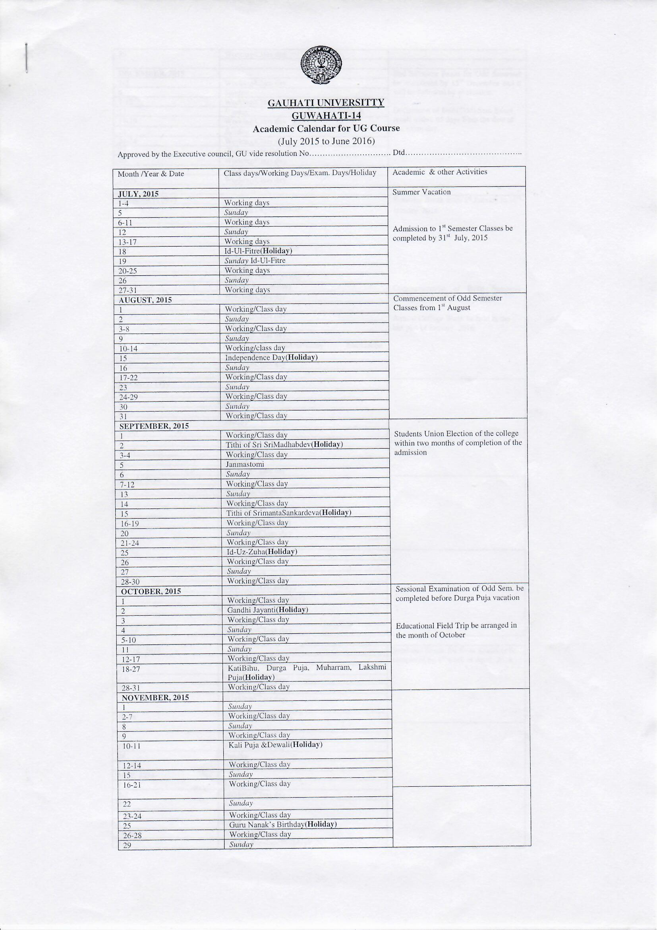

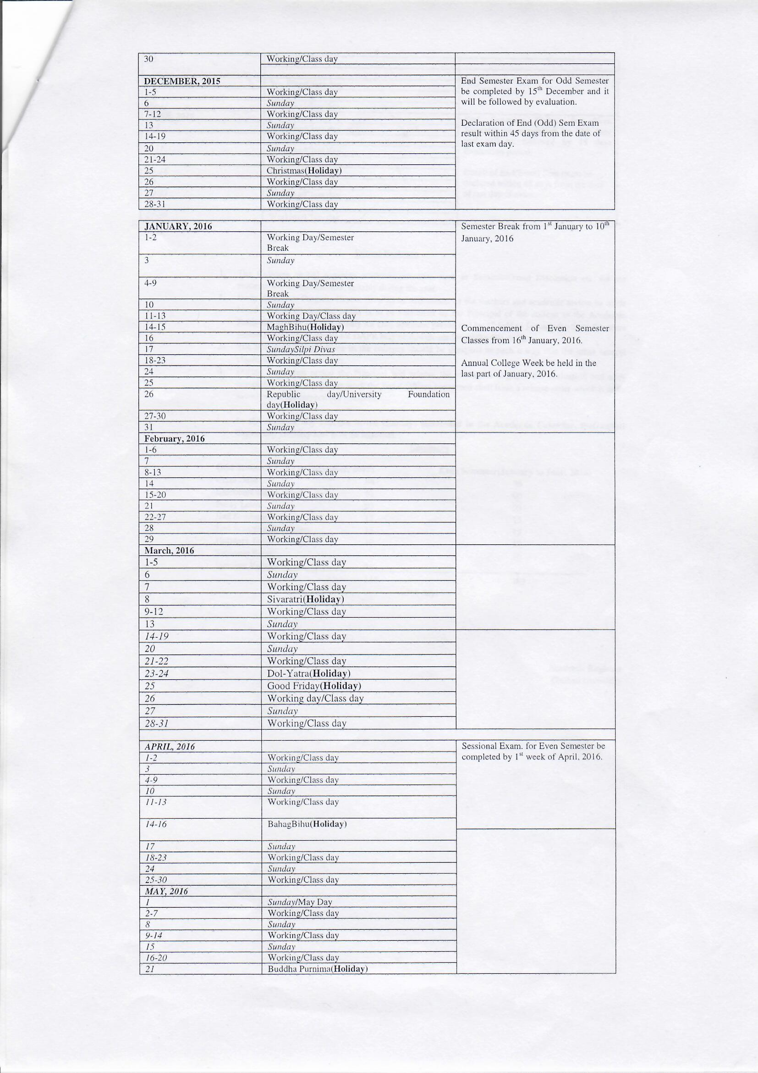

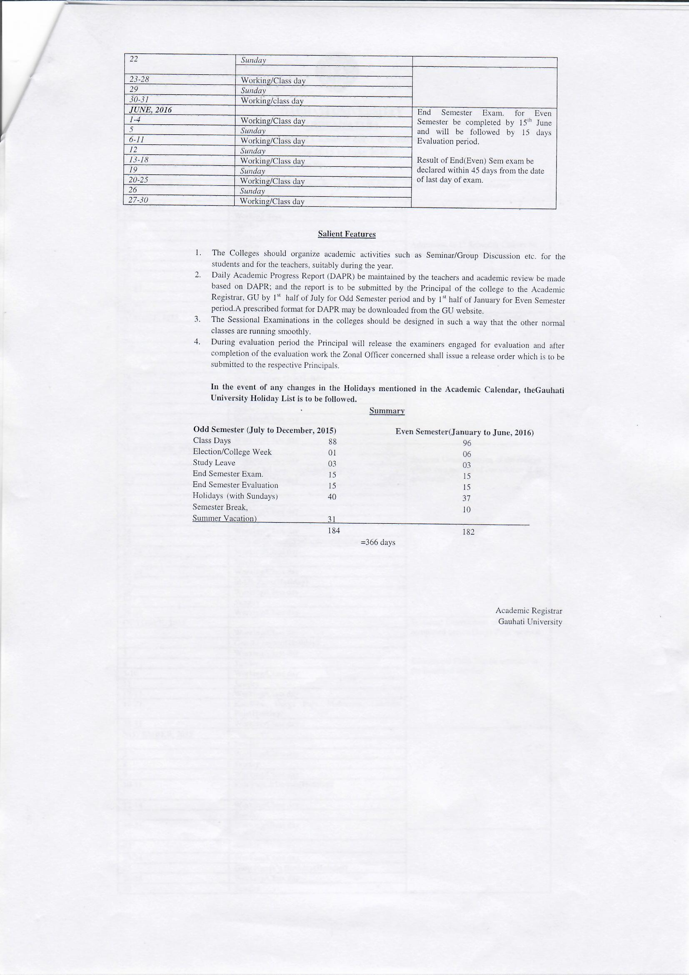

Annexure III-A
Graphical Representation of Student Feedback on Courses-
Course Feedback 2015-16
SL NO | Departments | Syllabus |  |  | Course Conceptuality |  |  |  | Teacher's Preparation for Class |  |  |  | Teacher's Communication |  | Students Participation in Class |  |  | Teacher's Approach
SL NO | Departments | Challenging | Adequate | Inadequate | Easy | Manageable | Difficult | Very Difficult | Thoroughly | Well | Poorly | Not at all | Effectively | Badly |  | YES | NO |  | Courteous | Rude | Indifferent
SL NO | Departments | Score in % |  |  | Score in % |  |  |  | Score in % |  |  |  | Score in % |  | Score in % |  |  | Score in %
1 | Political Science | 39 | 55 | 6 | 8 | 55 | 10 | 27 | 72 | 18 | 9 | 1 | 92 | 8 |  | 78 | 22 |  | 80 | 2 | 18
2 | Geography | 28 | 65 | 7 | 12 | 68 | 8 | 12 | 68 | 19 | 11 | 2 | 91 | 9 |  | 85 | 15 |  | 78 | 1 | 21
3 | Education | 12 | 70 | 18 | 11 | 56 | 13 | 20 | 54 | 28 | 11 | 7 | 92 | 8 |  | 72 | 28 |  | 75 | 5 | 20
4 | Physics | 14 | 65 | 21 | 14 | 58 | 20 | 8 | 59 | 21 | 10 | 10 | 89 | 11 |  | 74 | 26 |  | 78 | 2 | 20
5 | Botany | 10 | 75 | 15 | 8 | 72 | 10 | 10 | 72 | 12 | 7 | 9 | 93 | 7 |  | 77 | 23 |  | 87 | 3 | 10
6 | Zoology | 18 | 70 | 12 | 5 | 69 | 18 | 8 | 59 | 25 | 12 | 4 | 90 | 10 |  | 82 | 18 |  | 78 | 2 | 20
7 | History | 18 | 65 | 17 | 9 | 72 | 7 | 12 | 69 | 15 | 11 | 5 | 90 | 10 |  | 92 | 8 |  | 94 | 2 | 4
8 | English | 15 | 72 | 13 | 12 | 71 | 9 | 8 | 72 | 26 | 1 | 1 | 91 | 9 |  | 81 | 19 |  | 91 | 2 | 7
9 | Assamese | 11 | 72 | 17 | 5 | 70 | 20 | 5 | 59 | 36 | 2 | 3 | 92 | 8 |  | 74 | 26 |  | 89 | 1 | 10
10 | Chemestry | 15 | 69 | 16 | 8 | 58 | 10 | 24 | 69 | 26 | 2 | 2 | 93 | 7 |  | 87 | 13 |  | 91 | 1 | 8
11 | Economics | 9 | 78 | 13 | 8 | 59 | 10 | 23 | 69 | 20 | 9 | 2 | 95 | 5 |  | 80 | 20 |  | 95 | 1 | 4
12 | Sanskrit | 12 | 75 | 13 | 5 | 70 | 11 | 14 | 59 | 24 | 12 | 5 | 99 | 1 |  | 79 | 21 |  | 92 | 2 | 6
13 | Mathamatics | 9 | 78 | 13 | 9 | 68 | 10 | 13 | 71 | 21 | 4 | 4 | 97 | 3 |  | 77 | 23 |  | 85 | 3 | 11
14 | Statistics | 8 | 82 | 10 | 10 | 69 | 18 | 3 | 65 | 14 | 9 | 12 | 96 | 4 |  | 87 | 13 |  | 89 | 1 | 10
15 | Phylosophy | 12 | 69 | 19 | 8 | 69 | 13 | 10 | 68 | 15 | 8 | 9 | 95 | 5 |  | 89 | 11 |  | 94 | 2 | 4

SL NO | Departments | Syllabus |  |  | Course Conceptuality |  |  |  | Teacher's Preparation for Class |  |  |  | Teacher's Communication |  | Students Participation in Class |  | Teacher's Approach
SL NO | Departments | Challenging | Adequate | Inadequate | Easy | Manageable | Difficult | Very Difficult | Thoroughly | Well | Poorly | Not at all | Effectively | Badly | YES | NO | Courteous | Rude | Indifferent
SL NO | Departments | Score in % |  |  | Score in % |  |  |  | Score in % |  |  |  | Score in % |  | Score in % |  | Score in %
11 | Economics | 12 | 72 | 16 | 9 | 52 | 14 | 25 | 55 | 34 | 10 | 1 | 95 | 5 | 91 | 9 | 95 | 1 | 4
12 | Sanskrit | 10 | 79 | 11 | 15 | 55 | 12 | 18 | 69 | 28 | 1 | 2 | 99 | 1 | 78 | 22 | 92 | 2 | 6
13 | Mathamatics | 15 | 82 | 3 | 8 | 70 | 9 | 13 | 68 | 19 | 6 | 7 | 97 | 3 | 87 | 13 | 85 | 3 | 11
14 | Statistics | 35 | 55 | 10 | 8 | 75 | 12 | 5 | 69 | 18 | 5 | 8 | 96 | 4 | 69 | 31 | 85 | 2 | 13
15 | Phylosophy | 10 | 76 | 14 | 8 | 71 | 15 | 6 | 67 | 24 | 6 | 3 | 95 | 5 | 87 | 13 | 97 | 2 | 1
Annexure III-B
Graphical Representation of Student Feedback on Teachers-
Department: Arabic

Sl No | Teacher's Quality | Score out of 10
Sl No | Teacher's Quality | Teacher's Name
Sl No | Teacher's Quality | AA | AQ
1 | Communication skill | 9 | 9
2 | Interest generated by the teacher | 9 | 10
3 | Ability to integrate course material with environment/ other issues to provide a broader perspective | 10 | 9
4 | Ability to integrate across the courses/ other course | 9 | 10
5 | Accessibility of the teacher in and out of the class | 10 | 10
6 | Ability to design quizzes/ exam/ assignment | 9 | 9
7 | Provision of sufficient timely feedback | 8 | 8
8 | Knowledge base of the teacher | 10 | 10
9 | Sincerity/commitment of the teacher | 10 | 9
10 | Overall rating given by IQAC | 9.33 | 9.33

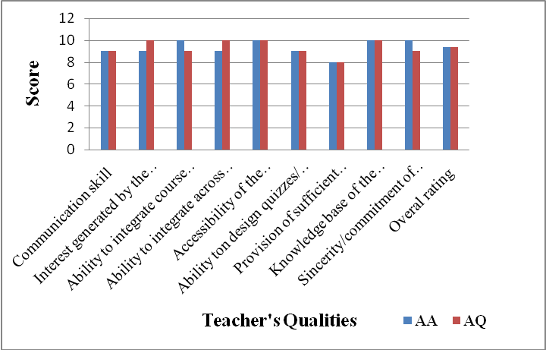
AA = Asser Uddin AQ = Dr. Abul Qasim

Department: Assamese
Sl No. | Teacher's Quality | Score out of 10
Sl No. | Teacher's Quality | Teacher's Name
Sl No. | Teacher's Quality | BKS | DB | BK | SPD | BB | MKB
1 | Communication skill | 10 | 8 | 10 | 8 | 9 | 10
2 | Interest generated by the teacher | 9 | 7 | 9 | 6 | 5 | 8
3 | Ability to integrate course material with environment/ other issues to provide a broader perspective | 10 | 10 | 10 | 7 | 5 | 7
4 | Ability to integrate across the courses/ other course | 10 | 9 | 9 | 9 | 8 | 9
5 | Accessibility of the teacher in and out of the class | 9 | 10 | 10 | 10 | 10 | 10
6 | Ability to design quizzes/ exam/ assignment | 10 | 10 | 9 | 9 | 9 | 9
7 | Provision of sufficient timely feedback | 10 | 10 | 10 | 10 | 10 | 10
8 | Knowledge base of the teacher | 9 | 7 | 9 | 6 | 8 | 8
9 | Sincerity/commitment of the teacher | 9 | 7 | 8 | 7 | 6 | 7
10 | Overall rating given by IQAC | 9.56 | 8.67 | 9.33 | 8 | 7.78 | 8.67

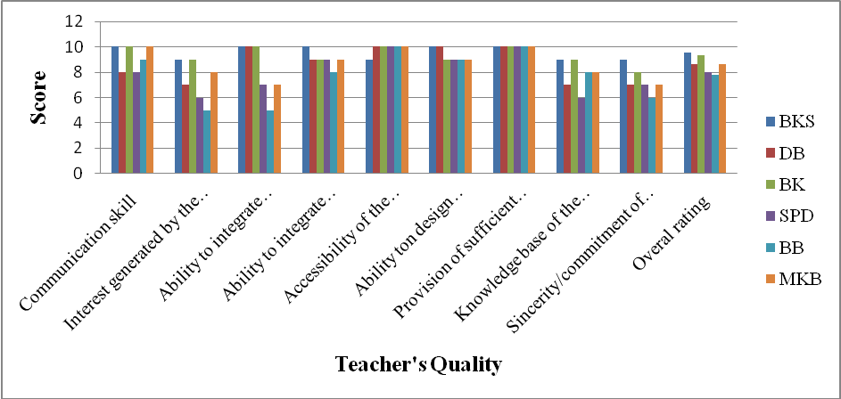
BKS = Dr. B.K.Sarma, DB = Dimbeswar Baruah, BK = Dr. Barnali Kalita,
SPD = Dr. Saraju Priya Devi, BB = Dr. Bijoya Borah, MKB = Mausumikansa Banik

Department: Botany
Sl No.
Sl No. | Teacher’s Qualities
Sl No. |  | PP | SS | PD | SA | SU
1 | Communication skill | 6 | 8 | 8 | 8 | 6
2 | Interest generated by the teacher | 6 | 6 | 8 | 8 | 6
3 | Ability to integrate course material with environment/ other issues to provide a broader perspective | 7 | 6 | 8 | 8 | 7
4 | Ability to integrate across the courses/ other course | 7 | 8 | 7 | 7 | 6
5 | Accessibility of the teacher in and out of the class | 6 | 8 | 7 | 7 | 6
6 | Ability to design quizzes/ exam/ assignment | 6 | 8 | 7 | 7 | 6
7 | Provision of sufficient timely feedback | 8 | 8 | 8 | 8 | 8
8 | Knowledge base of the teacher | 10 | 10 | 10 | 10 | 10
9 | Sincerity/commitment of the teacher | 10 | 10 | 10 | 10 | 10
10 | Overall rating given by IQAC | 7.33 | 8 | 8.11 | 8.11 | 7.22

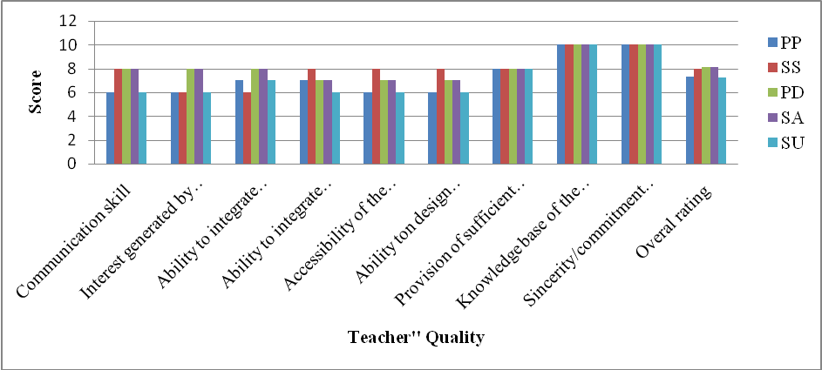
PP = Dr. Plabita Patwary, SS = Dr. Sachin Saharia, PD = Dr. Prativa Deka,
SA = Dr. Sahabuddin Ahmed, SU= Dr. Sristy Upadhyaya

Department: Chemistry
Sl No. | Teacher's Quality | Score Out of 10
Sl No. | Teacher's Quality | Teacher's Name
Sl No. | Teacher's Quality | NS | APS | KKB | PG | NI
1 | Communication skill | 4 | 10 | 9 | 4 | 4
2 | Interest generated by the teacher | 5 | 10 | 10 | 8 | 7
3 | Ability to integrate course material with environment/ other issues to provide a broader perspective | 6 | 10 | 9 | 8 | 7
4 | Ability to integrate across the courses/ other course | 6 | 10 | 9 | 9 | 8
5 | Accessibility of the teacher in and out of the class | 6 | 10 | 10 | 8 | 7
6 | Ability to design quizzes/ exam/ assignment | 7 | 10 | 8 | 8 | 7
7 | Provision of sufficient timely feedback | 5 | 10 | 8 | 8 | 8
8 | Knowledge base of the teacher | 4 | 9 | 9 | 10 | 8
9 | Sincerity/commitment of the teacher | 6 | 9 | 10 | 9 | 9
10 | Overall rating given by IQAC | 5.44 | 9.78 | 9.11 | 8 | 7.22

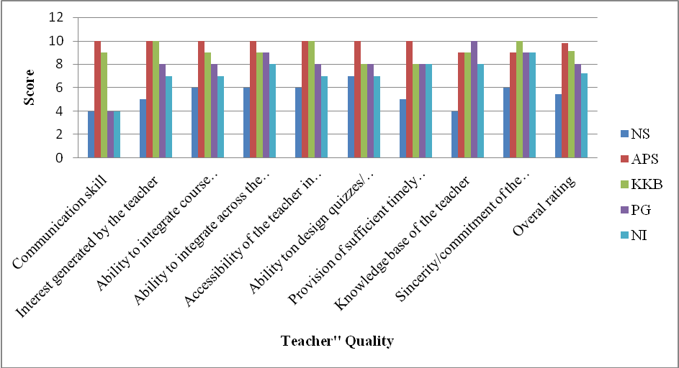
NS = Niranjan Sarma, APS = Dr. Atul Prashad Sikdar, KKB= Dr. Kamala Kanta Borah,
NI = Nashe-Ul-Islam, PG = Dr. Pankaj Kumar Ghosh

Department: Economics
Sl No. | Teacher's Quality | Score Out of 10
Sl No. | Teacher's Quality | Teacher's Name
Sl No. | Teacher's Quality | PKS | CG | US | SB
1 | Communication skill | 6 | 10 | 7 | 9
2 | Interest generated by the teacher | 8 | 10 | 7 | 8
3 | Ability to integrate course material with environment/ other issues to provide a broader perspective | 10 | 10 | 6 | 8
4 | Ability to integrate across the courses/ other course | 9 | 8 | 8 | 8
5 | Accessibility of the teacher in and out of the class | 7 | 8 | 7 | 7
6 | Ability to design quizzes/ exam/ assignment | 10 | 10 | 6 | 7
7 | Provision of sufficient timely feedback | 10 | 10 | 7 | 10
8 | Knowledge base of the teacher | 10 | 10 | 8 | 10
9 | Sincerity/commitment of the teacher | 5 | 10 | 6 | 10
10 | Overall rating given by IQAC | 8.33 | 9.56 | 6.89 | 8.56

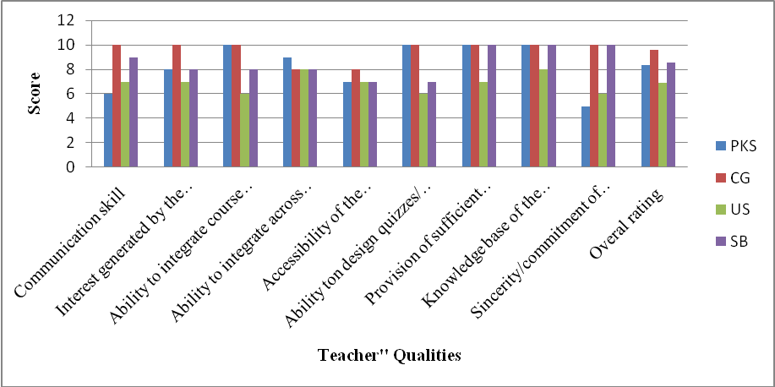
PKS = Paresh Kr. Sarma, CG = Dr. Chandrama Goswami, US = Umesh Sarma,
SB = Santosh Barkakati

Department of Education
Sl No | Teacher's Qualities | Score Out of 10
Sl No | Teacher's Qualities | Teacher's Name
Sl No | Teacher's Qualities | BS | UD | KB
1 | Communication skill | 10 | 10 | 10
2 | Interest generated by the teacher | 9 | 8 | 10
3 | Ability to integrate course material with environment/ other issues to provide a broader perspective | 9 | 9 | 10
4 | Ability to integrate across the courses/ other course | 6 | 7 | 9
5 | Accessibility of the teacher in and out of the class | 7 | 6 | 9
6 | Ability to design quizzes/ exam/ assignment | 10 | 9 | 10
7 | Provision of sufficient timely feedback | 8 | 7 | 9
8 | Knowledge base of the teacher | 10 | 10 | 10
9 | Sincerity/commitment of the teacher | 10 | 10 | 10
10 | Overall rating given by IQAC | 8.78 | 8.44 | 9.67

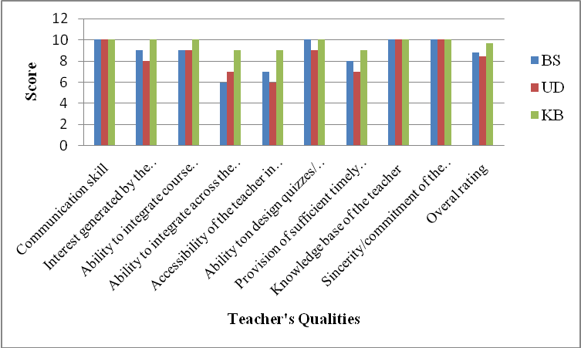
BS = Babita Sarma, UD = Usha Rani Deka, KB = Kunjalata Baruah

Department of Geography
Sl No | Teacher's Qualities | Score Out of 10
Sl No | Teacher's Qualities | Teacher's Name
Sl No | Teacher's Qualities | HD | PN | MS | JKB | PKS
1 | Communication skill | 8 | 9 | 5 | 7 | 10
2 | Interest generated by the teacher | 7 | 7 | 5 | 4 | 10
3 | Ability to integrate course material with environment/ other issues to provide a broader perspective | 9 | 8 | 7 | 6 | 10
4 | Ability to integrate across the courses/ other course | 8 | 7 | 9 | 8 | 10
5 | Accessibility of the teacher in and out of the class | 10 | 10 | 4 | 9 | 10
6 | Ability to design quizzes/ exam/ assignment | 9 | 8 | 6 | 9 | 10
7 | Provision of sufficient timely feedback | 8 | 7 | 7 | 4 | 10
8 | Knowledge base of the teacher | 9 | 9 | 8 | 5 | 10
9 | Sincerity/commitment of the teacher | 8 | 9 | 6 | 7 | 10
10 | Overall rating given by IQAC | 8.44 | 8.22 | 6.33 | 6.56 | 10.00

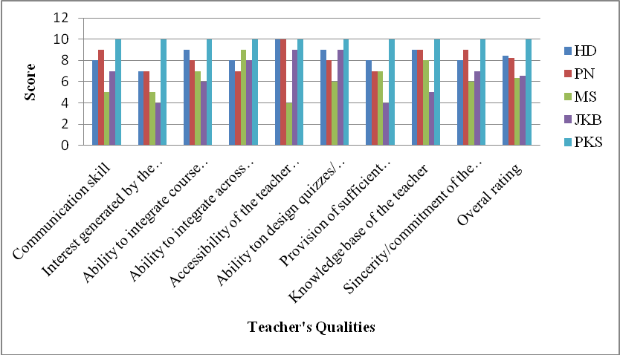
HD = Hariman Deka, PN = Pabitra Kumar Nath MS = Mukut Sarma
JKB = Dr. Jayanta Kumar Baruah PKS = Dr. Pranjit Kumar Sarma

Department of English
Sl No | Teacher's Qualities | Score Out of 10
Sl No | Teacher's Qualities | Teacher's Name
Sl No | Teacher's Qualities | MB | NM | RD
1 | Communication skill | 10 | 9 | 10
2 | Interest generated by the teacher | 9 | 9 | 9
3 | Ability to integrate course material with environment/ other issues to provide a broader perspective | 8 | 7 | 7
4 | Ability to integrate across the courses/ other course | 9 | 9 | 8
5 | Accessibility of the teacher in and out of the class | 10 | 9 | 9
6 | Ability to design quizzes/ exam/ assignment | 9 | 10 | 9
7 | Provision of sufficient timely feedback | 9 | 7 | 9
8 | Knowledge base of the teacher | 10 | 10 | 10
9 | Sincerity/commitment of the teacher | 10 | 10 | 10
10 | Overall rating given by IQAC | 9.33 | 8.89 | 9.00

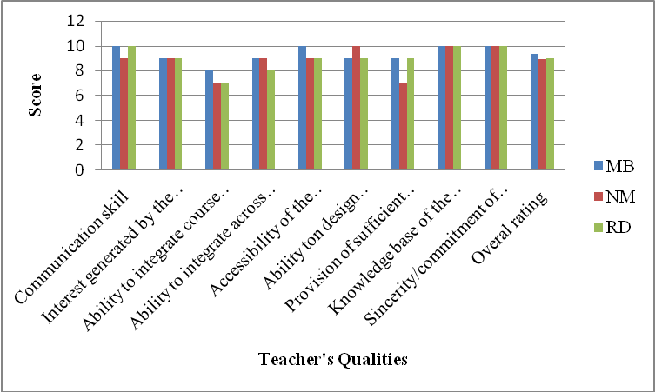
MB = Manimugdha Barthakur, NM = Dr. Niharanjan Mishra RD = Dr. Runjun Devi

Department of History
Sl No. | Teachers’ Qualities | Score Out of 10
Sl No. | Teachers’ Qualities | Teacher’s Name
Sl No. | Teachers’ Qualities | SG | AS | MD
1 | Communication skill | 8 | 10 | 8
2 | Interest generated by the teacher | 7 | 10 | 8
3 | Ability to integrate course material with environment/ other issues to provide a broader perspective | 7 | 9 | 7
4 | Ability to integrate across the courses/ other course | 6 | 10 | 7
5 | Accessibility of the teacher in and out of the class | 6 | 10 | 7
6 | Ability to design quizzes/ exam/ assignment | 6 | 9 | 8
7 | Provision of sufficient timely feedback | 7 | 10 | 10
8 | Knowledge base of the teacher | 8 | 10 | 8
9 | Sincerity/commitment of the teacher | 8 | 10 | 8
10 | Overall rating given by IQAC | 7.00 | 9.78 | 7.89

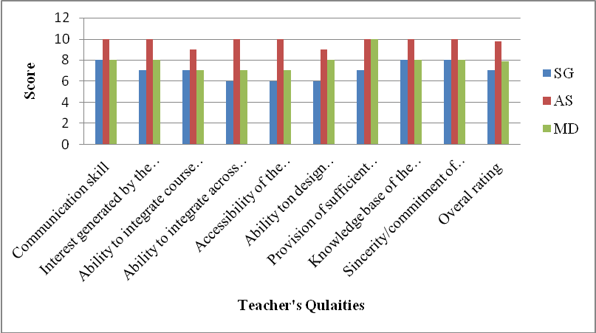
SG = Dr. Sangita Gogoi, AS = Dr. Angiras Sarma MD = Dr. Mridul Deka

Department of Mathematics
Sl. No | Teacher's Qualities | Score out of 10
Sl. No | Teacher's Qualities | Teacher’s Name
Sl. No | Teacher's Qualities | PB | DN | DK | JK
1 | Communication skill | 10 | 7 | 10 | 7
2 | Interest generated by the teacher | 5 | 5 | 5 | 6
3 | Ability to integrate course material with environment/ other issues to provide a broader perspective | 8 | 8 | 9 | 9
4 | Ability to integrate across the courses/ other course | 10 | 10 | 10 | 10
5 | Accessibility of the teacher in and out of the class | 6 | 6 | 6 | 6
6 | Ability to design quizzes/ exam/ assignment | 7 | 7 | 9 | 7
7 | Provision of sufficient timely feedback | 10 | 10 | 10 | 10
8 | Knowledge base of the teacher | 10 | 10 | 10 | 9
9 | Sincerity/commitment of the teacher | 10 | 10 | 10 | 10
10 | Overall rating given by IQAC | 8.44 | 8.11 | 8.78 | 8.22

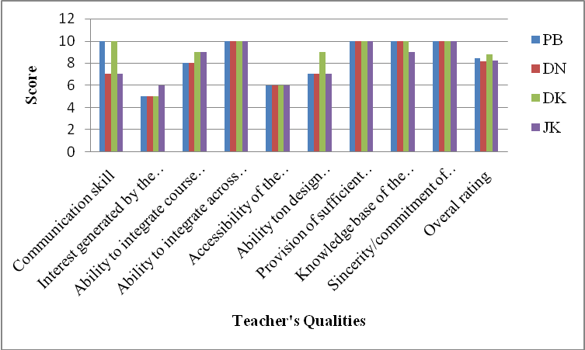
PB = Prafula Bora, DN = Debajit Nath, DK = Dimbeswar Kalita

Department of Philosophy
Sl No. | Teacher's Qualities | Score out of 10
Sl No. | Teacher's Qualities | Teacher’s Name
Sl No. | Teacher's Qualities | PB | BH | ND
1 | Communication skill | 5 | 6 | 9
2 | Interest generated by the teacher | 6 | 5 | 10
3 | Ability to integrate course material with environment/ other issues to provide a broader perspective | 7 | 6 | 10
4 | Ability to integrate across the courses/ other course | 6 | 7 | 9
5 | Accessibility of the teacher in and out of the class | 7 | 7 | 9
6 | Ability to design quizzes/ exam/ assignment | 7 | 7 | 7
7 | Provision of sufficient timely feedback | 8 | 6 | 10
8 | Knowledge base of the teacher | 9 | 8 | 10
9 | Sincerity/commitment of the teacher | 6 | 7 | 9
10 | Overall rating given by IQAC | 6.78 | 6.56 | 9.22

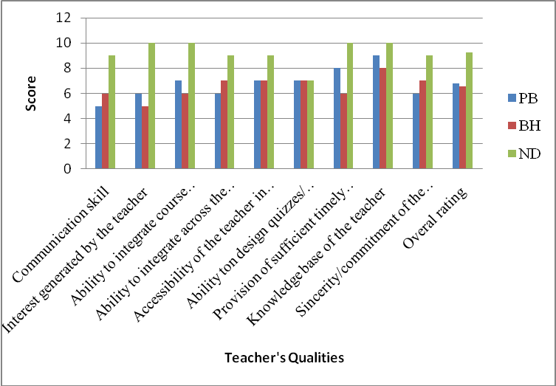
PB = Prabin Baruah, BH = Bhupen Haloi, ND = Nabajyoti Doley

Department of Physics
Sl No | Teacher's Qualities | Score out of 10
Sl No | Teacher's Qualities | Teacher’s Name
Sl No | Teacher's Qualities | BC | RS | KS | SP
1 | Communication skill | 9 | 7 | 8 | 5
2 | Interest generated by the teacher | 9 | 8 | 8 | 6
3 | Ability to integrate course material with environment/ other issues to provide a broader perspective | 9 | 9 | 9 | 5
4 | Ability to integrate across the courses/ other course | 8 | 8 | 9 | 5
5 | accessibility of the teacher in and out of the class | 7 | 8 | 8 | 5
6 | ability to design quizzes/ exam/ assignment | 7 | 8 | 8 | 8
7 | Provision of sufficient timely feedback | 7 | 8 | 7 | 6
8 | Knowledge base of the teacher | 10 | 10 | 10 | 10
9 | Sincerity/commitment of the teacher | 9 | 9 | 9 | 5
10 | Overall rating given by IQAC | 8.33 | 8.33 | 8.44 | 6.11

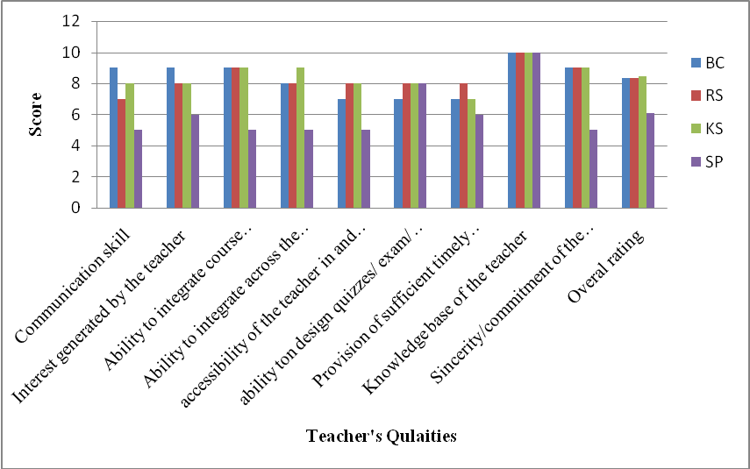
BC = Bhabesh Choudhury, RN = Dr. Ranjan Sarma, KS = Dr. Kankan Sarma,
SP = Dr. Susmita Paul
Department of Political Science
Sl No. | Teacher's Qualities | Score Out of 10
Sl No. | Teacher's Qualities | Teacher's Names
Sl No. | Teacher's Qualities | IN | BD | AT
1 | Communication skill | 8 | 10 | 9
2 | Interest generated by the teacher | 8 | 10 | 9
3 | Ability to integrate course material with environment/ other issues to provide a broader perspective | 8 | 9 | 8
4 | Ability to integrate across the courses/ other course | 9 | 9 | 9
5 | Accessibility of the teacher in and out of the class | 8 | 9 | 8
6 | Ability to design quizzes/ exam/ assignment | 9 | 9 | 9
7 | Provision of sufficient timely feedback | 8 | 9 | 8
8 | Knowledge base of the teacher | 9 | 10 | 9
9 | Sincerity/commitment of the teacher | 9 | 10 | 8
10 | Overall rating given by IQAC | 8.44 | 9.44 | 8.56

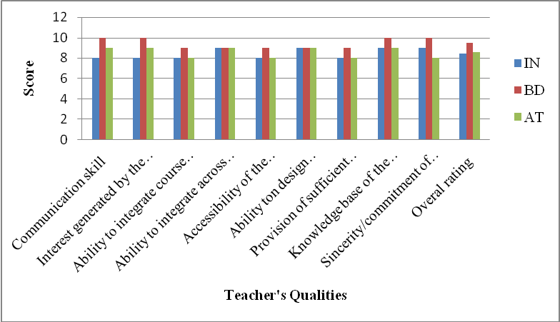
IN = Isha Ran Nath, BD = Dr. Barnali Deka, AT = Dr. Anupam Thakuria

Department of Sanskrit
Sl No. | Teacher's Qualities | Score out of 10
Sl No. | Teacher's Qualities | Teacher's Name
Sl No. | Teacher's Qualities | GK
1 | Communication skill | 8
2 | Interest generated by the teacher | 8
3 | Ability to integrate course material with environment/ other issues to provide a broader perspective | 9
4 | Ability to integrate across the courses/ other course | 7
5 | accessibility of the teacher in and out of the class | 6
6 | ability ton design quizzes/ exam/ assignment | 8
7 | Provision of sufficient timely feedback | 9
8 | Knowledge base of the teacher | 7
9 | Sincerity/commitment of the teacher | 10
10 | Overall rating given by IQAC | 8

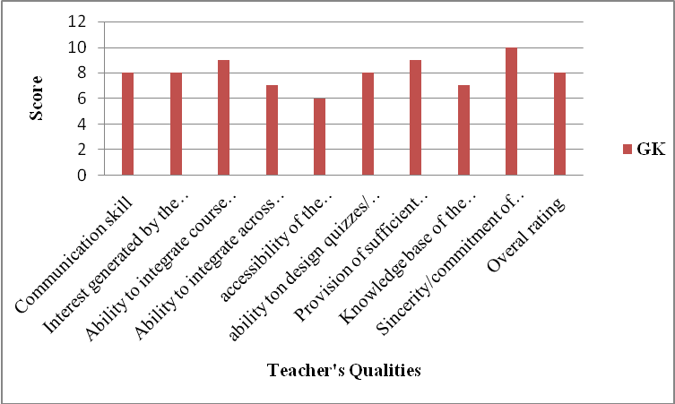
GK = Gagen Kakati

Department of Statistics
Sl No. | Teacher's Name | Score Out of 10
Sl No. | Teacher's Name | Teacher's Name
Sl No. | Teacher's Name | RS | RG | PD
1 | Communication skill | 6 | 7 | 6
2 | Interest generated by the teacher | 4 | 6 | 6
3 | Ability to integrate course material with environment/ other issues to provide a broader perspective | 3 | 5 | 5
4 | Ability to integrate across the courses/ other course | 2 | 5 | 5
5 | accessibility of the teacher in and out of the class | 2 | 4 | 4
6 | ability to design quizzes/ exam/ assignment | 3 | 6 | 7
7 | Provision of sufficient timely feedback | 3 | 7 | 7
8 | Knowledge base of the teacher | 4 | 8 | 8
9 | Sincerity/commitment of the teacher | 3 | 7 | 7
10 | Overall rating given by IQAC | 3.33 | 6.11 | 6.11

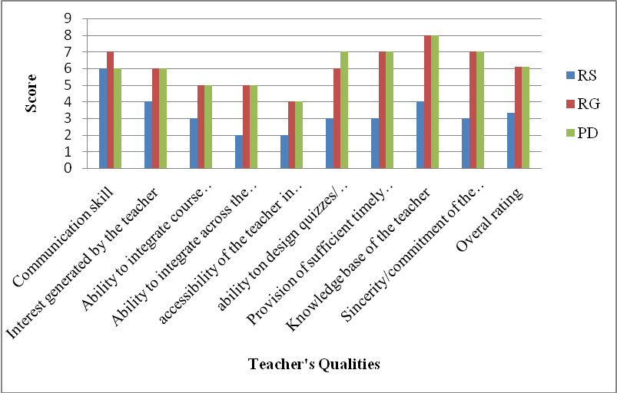
RS = Ramesh Sarma, RG = Ranjita Goswami, PD = Pranab Das

Department of Zoology
Sl No. | Teacher's Qualities | Score Out of 10
Sl No. | Teacher's Qualities | Teacher's Name
Sl No. | Teacher's Qualities | DD | PKS | LS | MS | SJ
1 | Communication skill | 9 | 7 | 10 | 10 | 9
2 | Interest generated by the teacher | 9 | 7 | 10 | 9 | 9
3 | Ability to integrate course material with environment/ other issues to provide a broader perspective | 8 | 9 | 9 | 10 | 10
4 | Ability to integrate across the courses/ other course | 7 | 7 | 8 | 7 | 8
5 | Accessibility of the teacher in and out of the class | 7 | 6 | 9 | 9 | 9
6 | Ability to design quizzes/ exam/ assignment | 10 | 6 | 10 | 8 | 9
7 | Provision of sufficient timely feedback | 9 | 7 | 10 | 10 | 10
8 | Knowledge base of the teacher | 10 | 10 | 10 | 10 | 10
9 | Sincerity/commitment of the teacher | 10 | 9 | 10 | 10 | 9
10 | Overall rating given by IQAC | 8.78 | 7.56 | 9.56 | 9.22 | 9.22

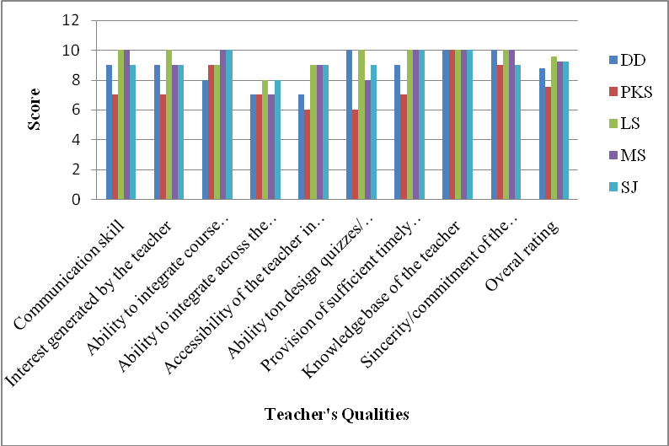
DD = Dipa Devi, PKS = Dr. Pranab Kr. Sarma, LS = Dr. Leena Saikia
MS = Dr. Minati Sarma, SJ = Dr. Seema Jyoti

Annexure IV
Best Practice-1

- Title of the Practice :
Presentation of STAR STUDENT AWARD for the best UG student in Botany, Chemistry, Physics and Zoology.
- Goal :
The STAR STUDENT AWARDs in Botany, Chemistry, Physics and Zoology have been initiated from the academic session 2014-15 under Star College Scheme sponsored by the Department of Biotechnology, Govt. of India with the following aims and objectives :
- To find the best UG student in the department of Botany, Chemistry, Physics and Zoology on the basis of academic performance and other co- & extra-curricular activities.
- To provide encouragement among the students to attend classes regularly, perform well in examination and participate in various co- & extra-curricular activities.
- To provide training for soft skill and personality development to face interviews in future.
- To provide quality PG level books to the awardees for higher study.
- To provide one month summer hands-on training to the awardees at the Intuitional Level Biotech Hub of the college.
- The Context :
Conferring award to the best performer in any event not only recognises the achievement but also provides encouragement and inspiration to the future participants. It also brings about the competitive environment among the participants. In this context, Mangaldai College introduced STAR STUDENT AWARD’ in Botany, Chemistry, Physics and Zoology coming under the DBT-STAR COLLEGE SCHEME for the best student in each department to create a competitive academic environment among the students in the science departments. The award not only stimulates and promotes the students to perform well but also improves overall academic atmosphere of the college.

- The Practice :
Mangaldai College for the first time, introduced the ‘STAR STUDENT AWARD’ in Botany, Chemistry, Physics and Zoology for the best student in each department. The selection procedure is strict and transparent which involves nomination of three 6th semester Major students from each department on the basis of academic performance. The 12 nominated candidates from the four departments are interviewed by a selection committee and the best candidates from each department are selected on the basis of academic performance, quality of report on visit to research institution, performance in Research Methodology paper, co and extracurricular activities, communication skill and overall interview performance. The details of the selection procedure are mentioned below :
- Submission of Nomination forms containing details of the students to the Departmental Head/ co-ordinator.
- Selection of 3 nominees from each Department by the faculty members on the basis of merit (CGPA obtained in Major up to 4th semester final Exam.).
- Final evaluation for the award by the selection committee considering the following criteria :
- Academic Performance (40 Marks)
- Evaluation of the report on Educational Tour (10 Marks)
- Performance in the paper on Research Methodology (10 Marks)
- Communication Skill (10 Marks)
- Knowledge regarding the College and the Department (10 Marks)
- Co-and extracurricular activities (10 Marks)
- Overall interview performance (10 Marks).
The best students are then awarded in a well gathered presentation ceremony in presence of a renowned scientist as the chief guest.
In the academic session 2015-16, the STAR STUDENT AWARD was conferred to Sayad Abdul Hai in Botany, Mr. Manash Pratim Nath in Chemistry, Mr. Krishna Bhuyan in Physics and Ms. Ruma Saharia in Zoology. The awards were presented in a presentation ceremony held on 30-03-2016 by the chief guest Prof. Probodh Borah of Assam Agricultural University, Khanapara, Guwahati.

- Evidences of Success :
The award was launched in 2014 and the award was presented in March, 2015. Due to this award, the following evidences of success are observed-
- Increase in percentage of attendance in classroom.
- Improvement of regularity and sincerity of both students and teachers
- Improvement in the cut-off % of enrolment in Science Major and General :
- Improvement in the Examination result.
- Pursuance of M.Sc. by the awardees.
- Appreciation by the society at large.

- Problems Encountered and Resources Required :
The awards were stated with the fund provided by the Department of Biotechnology, Govt. of India for a three year period. In future, the college have to become self-reliant regarding the resource to continue the practice.

Contact Details :
Name of the Principal : Dr. Khagendra Kumar Nath
Name of the Institution : Mangaldai College
City : Mangaldai
Pin Code : 784 125
Accredited Status : C⁺⁺ (2004)
Work Phone : 03713-230036 Fax : 03713-230036
Website : mangaldaicollege.org E-mail : principalnath@gamil.com
Mobile : 094351 85896

Annexure V
Best Practice-2

- Title of the Practice: Rendering community service by Blood Donation
- The context: As per the latest estimates the annual requirement of blood in India is around 1.2 core units per annum which reflect that India faces 10 percent shortage in estimated blood requirements. The scenario was even far worse five years back. As a result many people lost their lives for the want of pure safe blood transfusion. It is reported frequently that the only blood bank of Darrang district also faces acute shortage of blood. So, Mangaldai College, being the pioneer higher educational institute in the district of Darrang it focuses for community improvement by involving students, faculty, NGO and other stake holders of the institution.
- Objectives of the Practice: The objective of the practice is to encourage students, faculty, stake holders to have closer ties between institution and communities they serve with. Most importantly to make our learners to be more responsible towards the community and to enhance community participation is another objective of the practice. To make blood transfusion accessible who are in dire need of blood. To increase civic sense of the students.
- The practice: Mangaldai College organizes regular blood donation camps with the help of the NCC wings of the college in collaboration with Crystal Vision (NGO) and with the technical support from the Blood Bank at Mangaldai Civil Hospital. During the last five years the college and its NGO partner have been able to organize eight numbers of blood donation camps and a total of 309 units of Blood have been donated to the Blood Bank of the Civil Hospital, Mangaldai. The Institution aims at ensuring easy accessibility and adequate supply of safe and quality blood and blood components collected from voluntary blood donors to those in need. The blood is stored and transported under optimum conditions with the help of Blood Bank Authority. The practice tries to make blood transfusion available to people irrespective of their economic or social status. The college also gives emphasis on Total Quality Management for smooth conduct of Blood Donation Camps and follow-up work.
- Evidence of success: The gradual increase of volunteer donors in successive camps is one of the evidences of our success. The blood collected from the camps has been utilised by the persons suffering from different critical illness and lots of people have been benefited as reported by the blood bank authority. It has also been reported that the significant amount of blood collected from the camps organized in the last five years jointly by NCC, Mangaldai College and its partner NGO, Crystal vision has contributed significantly in the mitigation of acute shortage of blood in the Mangaldai Civil Hospital. Increase in civic responsibility, reduced indiscipline and enhanced sense of responsibility is apparent among the students towards the college is also an evidence of success.
- Problems encountered and Resources Required: The Main obstacle faced during the practice is misgivings and apprehension among the people regarding blood donation. However, organizing some awareness programme like celebrating blood donor day every year on 14th June, organizing cycle rally for the awareness have helped to overcome the problem. Financial constraint is another problem to organize massive awareness programme in regular manner for rooting out the public misconception regarding blood donation. The problem is overcome by our NGO partner and community involvement.
- Note: The practice has made an impact on community, students, and teachers. Awareness on Blood donation among students, teachers and community is increasing. The gradual increase in numbers of donors in successive blood donation camps indicates that the institution is going to achieve its objective. To sustain the practice we need to comprehend that blood donation costs us nothing but saves a life.
Contact Details :
Name of the Principal : Dr. Khagendra Kumar Nath
Name of the Institution : Mangaldai College
City : Mangaldai
Pin Code : 784 125
Accredited Status : C⁺⁺ (2004)
Work Phone : 03713-230036 Fax : 03713-230036
Website : mangaldaicollege.org E-mail : principalnath@gamil.com
Mobile : 094351 85896

Annexure VI
SWOT Analysis

S :
- A spacious green campus of 33.56 acres of land with potentiality for future requirement.
- Qualified teaching staff with 28 Ph.D. degree holders.
- Inclusive and high enrolment of students.
- Low dropout rate.
- IBT Hub facilities encourage the faculty members to prepare research proposals to various funding agencies.
- Establishment of Central Instrumentation Centre.
- Participation of alumni in college developmental activities through Alumni Association.
- Improvement of laboratory facilities in Botany, Chemistry, Physics and Zoology from the grant under ‘STAR COLLEGE SCHEME’ sanctioned by the Department of Biotechnology, Government of India, in addition to existing IBT Hub.
- Participation of science students in various student centric activities organized under DBT-STAR COLLEGE SCHEME.
W :
- Lack of PG courses and other career oriented courses.
- No formal feed-back from parents.
- Delay in filling up the vacancies of teaching and non-teaching posts due to long Government procedures.
- Incomplete boundary wall.
- Inability to obtain more major research grants.
- Limited research publications by the faculty.
- Nominal participation of students in State/National/International events.
- Low frequency of extension activities.
- Limited infrastructure and inadequate teaching staff to meet the burgeoning demand for enrolment.
- Limited student counselling.
- Limited industry interaction/collaboration.
- No significant activities and support from alumni.
- No formal parent-teacher association.
O :
- Scope for opening of PG courses in Botany, Chemistry, Physics, Geography and Zoology in a phased manner.
- Scope for improvement of teaching-learning process on the feed-back obtained from the parent-teacher meets.
T :
- Delay in filling up of vacant posts of teaching and non-teaching staff.
- Non-creation of new teaching and non-teaching posts.
- Shortage of class-rooms and infrastructure to meet the growing demand.
- Encroachment of College land by the neighbours due to incomplete structural barrier.
- Less steps taken to strengthen the programmes on career guidance, health check up and care and extension activities.
- Extra class load for the teachers for H.S. courses in U.G. Colleges.

